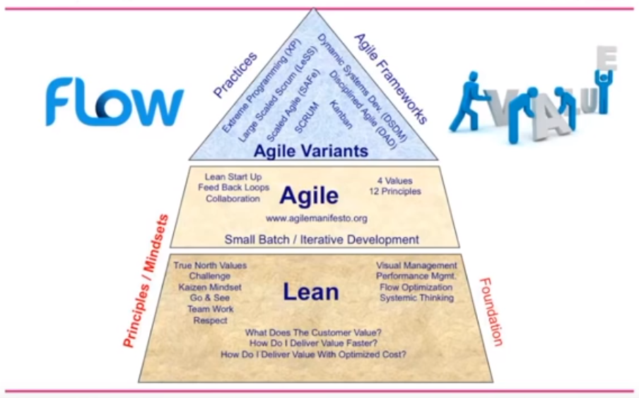

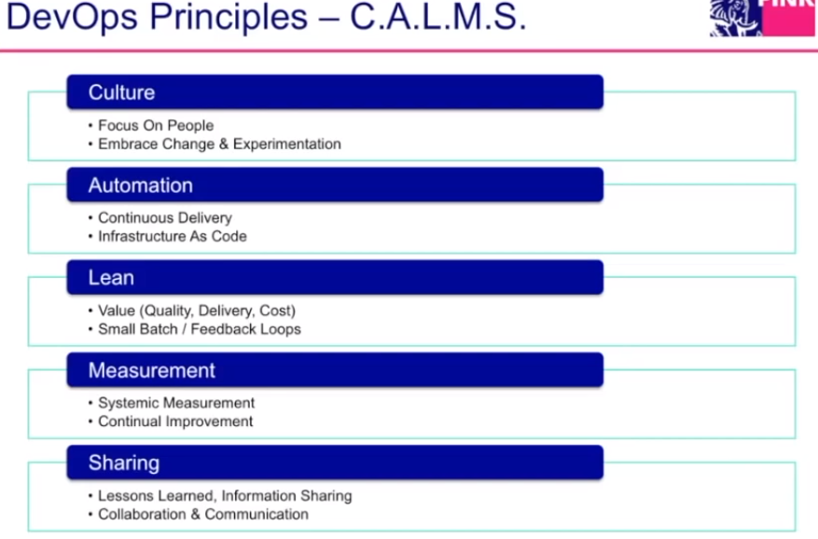

[**https://www.ebgconsulting.com/blog/**](https://www.ebgconsulting.com/blog/) **for agile best blogs**

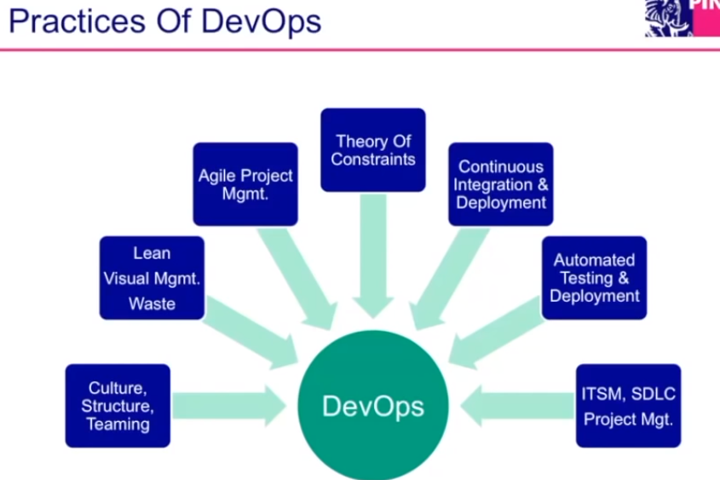

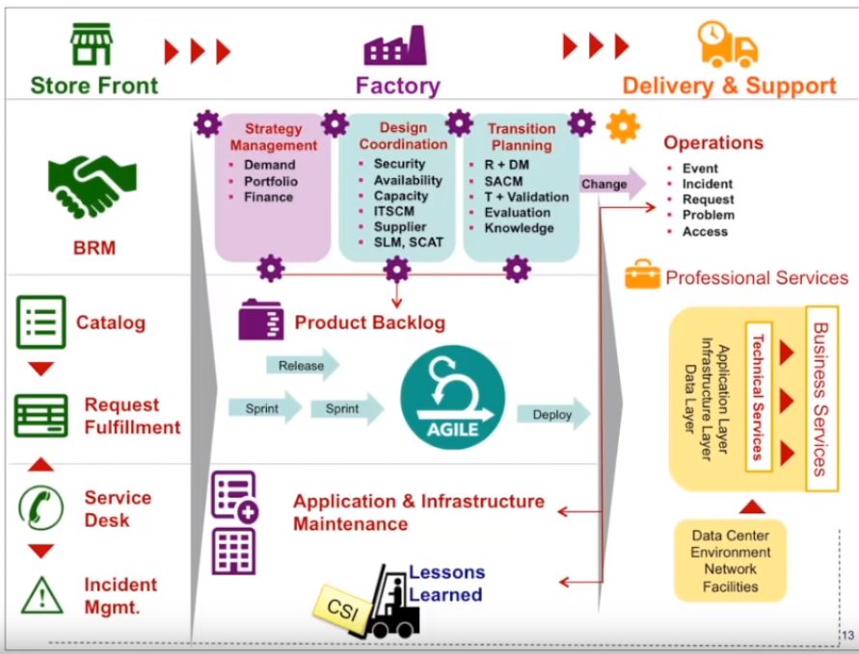

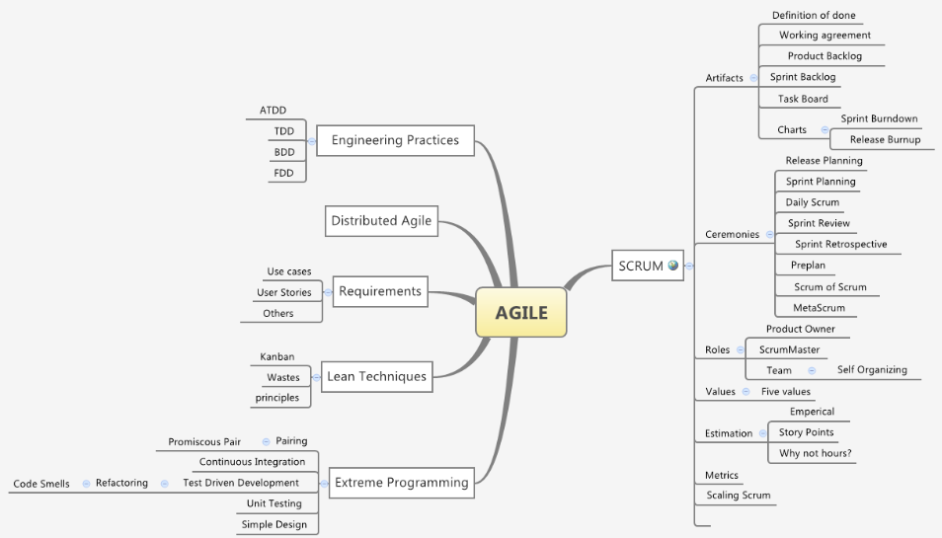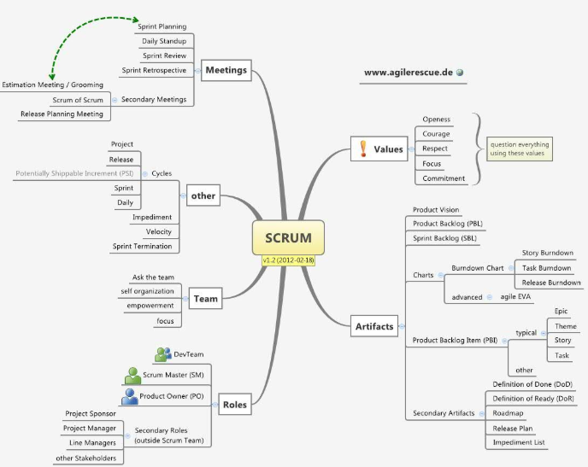

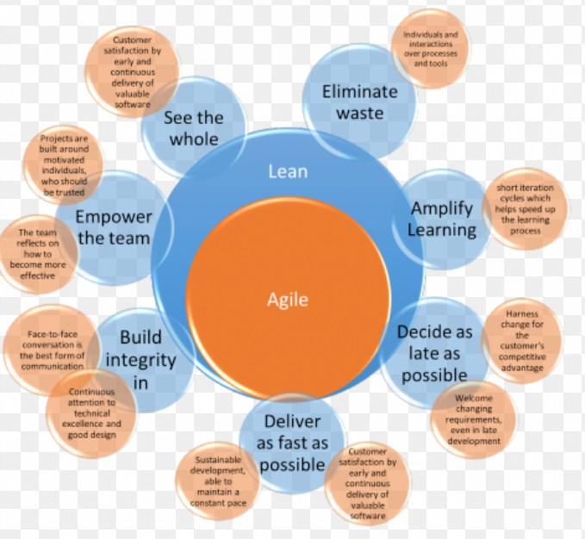

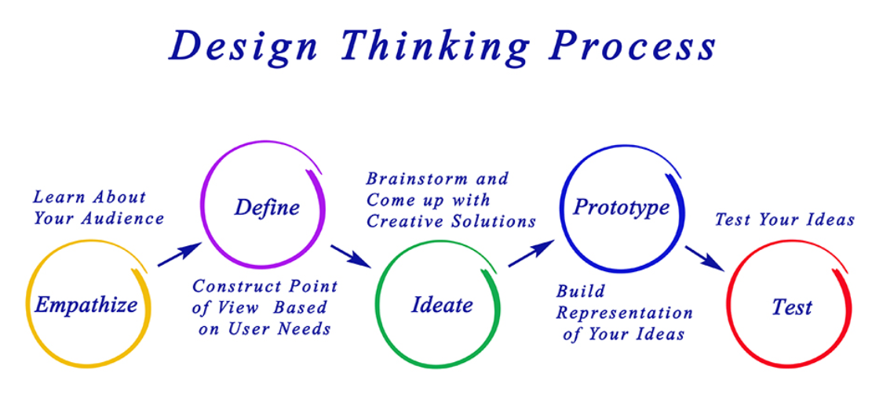

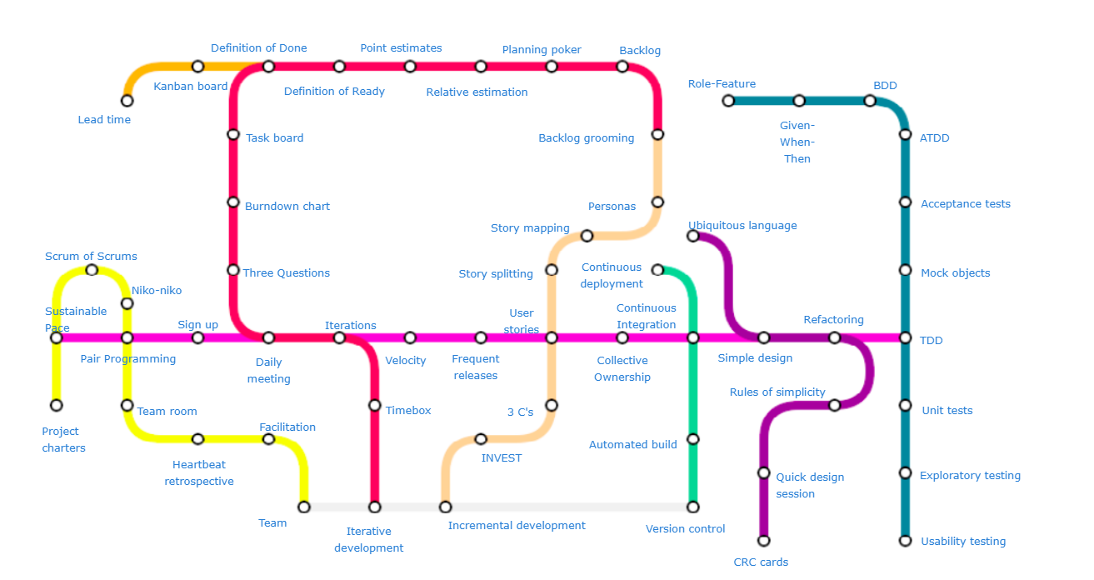

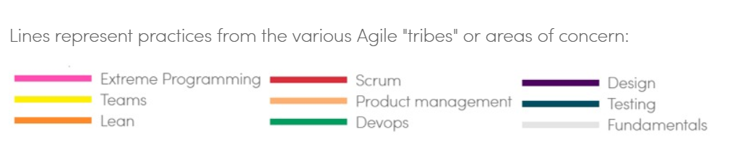

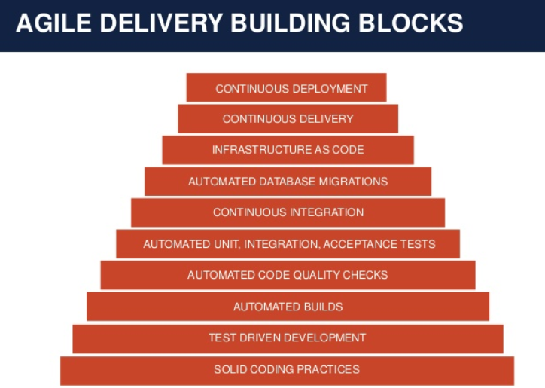

The **Product Backlog**, which lists all the features that make up the entire product.

The **Sprint Backlog**, which include the features we've committed to deliver in the next iteration.

The **Changes report**, which details the differences between the Product Backlog and the Sprint Backlog.

The **Burndown report** or chart, which illustrates (usually in the form of a trend graph) the work we've actually "burned through," giving us a real-world view of the team's progress.

A **burn down chart** shows how much work is remaining to be done in the project, whereas a **burn up** shows how much work has been completed, and the total amount of work.

The **Velocity chart**, it’s probably always good to track velocity, in terms of number of stories or story points. It can also be of value to show how your velocity is being spent, in terms of defect fixes or changes to previous stories.

**Sprint Tracking** Gantt charts are a simple, visual way to track tasks across the lifecycle of a project. In Agile PM, teams are doing sprints, which are basically short clusters of related tasks. A Gantt chart is a helpful way to capture and plan this work.

Gantt diagrams are bar charts that illustrate project schedules, and help visualize the start and end dates of any process. The primary purpose of using Agile is to enable developers to react to changing requirements faster.

As simple visual representations of the progress made against estimates on any activity, process or project, Gantt charts can greatly facilitate communication by bridging cultural or geographical differences.

Since these diagrams are easily understood by all parties regardless of language or expertise in agile software development practices, they are useful tools when trying to collaborate with, or report on their progress to several teams and departments across various regions.

**As requirements change, the effort and time needed to address them changes, too. Therefore, in order to adequately represent and visualize the total amount of work left, Gantt charts would have to be updated almost continuously.**

If you think recording *all* errors helps quality, why stop at bugs that you find as a tester? Why no record bugs that the compiler finds? Why not record unmatched parenthesis or uninitialized variables, which the compiler reports about?

**Three rules-of-thumb and one workflow:**

1. Within a Sprint, you do not waste time recording bugs - you fix them.
2. You do not deliver work with known errors because it is not 'done'. You don't need to file bugs on work item N, because the programmer is not 'done' with work item N. He is only 'done' when everyone agrees it is done, it complies with the definition of done, and there are no errors in it (not that I just said the same thing in 3 different ways). Only then does the programmer go on to the next work item. So there is no need to record the error.
3. When dealing with an error, especially from other Sprints or Teams, follow this workflow:
   * Can the programmer fix it in < 4 hours? If YES, then fix it. Done
   * If not, can the Team fit it in the current Sprint? If YES, then put it on the Scrum board and fix it. Done.
   * If not, take it up with the Product Owner. The error cannot be fixed in the current Sprint. Can he place the error as a Product Backlog Item on the Product Backlog to be fixed later? If YES, then put it on the PB.
   * Last and least desirable option: If it can't be fixed together with the current Sprint, and it can't be postponed, the PO can abort the current Sprint. The Team moans and then fixes the error.
4. Feature request: it’s true that sometimes people get confused on what is a bug and what is a new feature request. If a bug report is found to be a new feature request, the request is transferred to the product backlog, turned into a story, and prioritized by the product owner. The bug is closed.

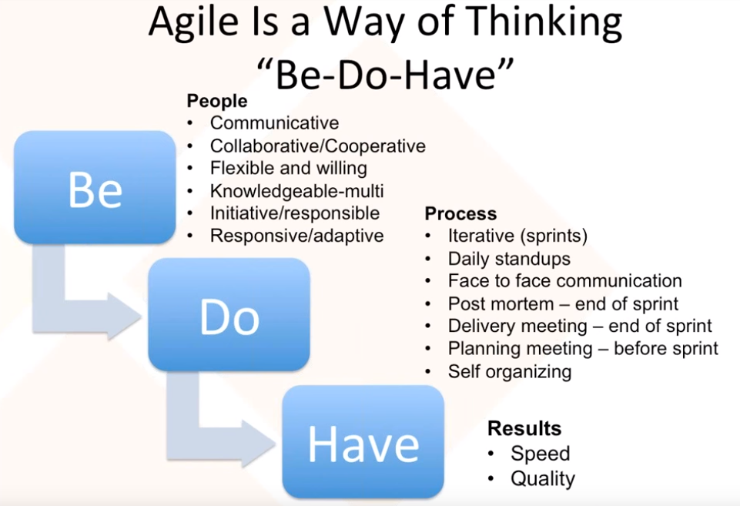

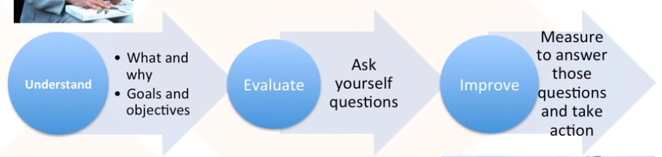

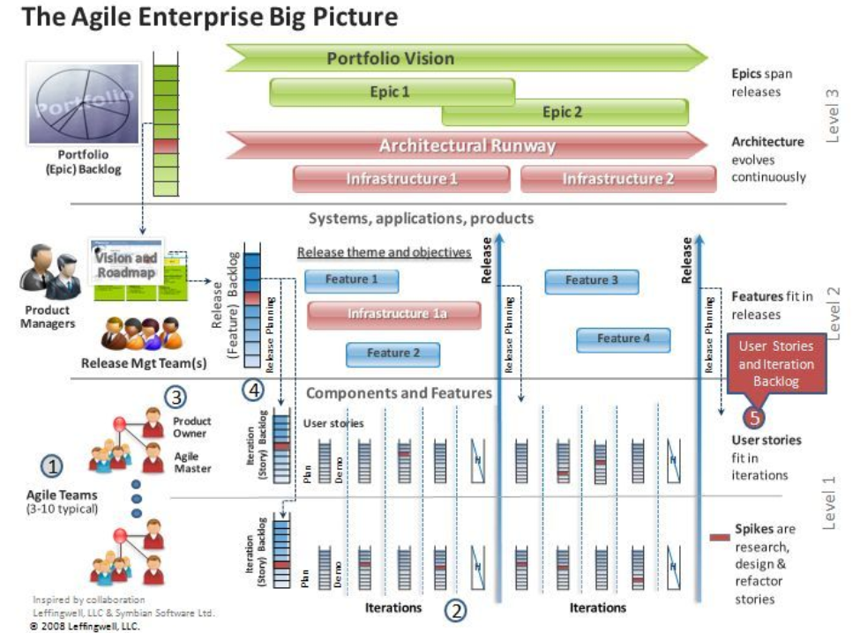

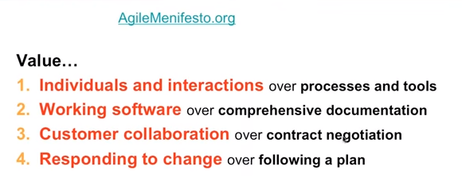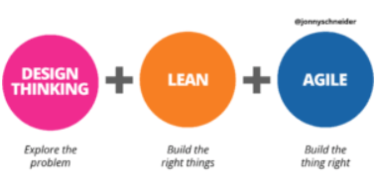

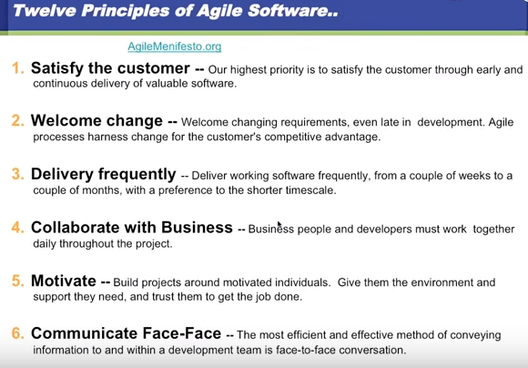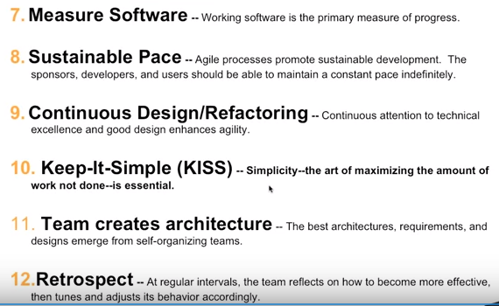

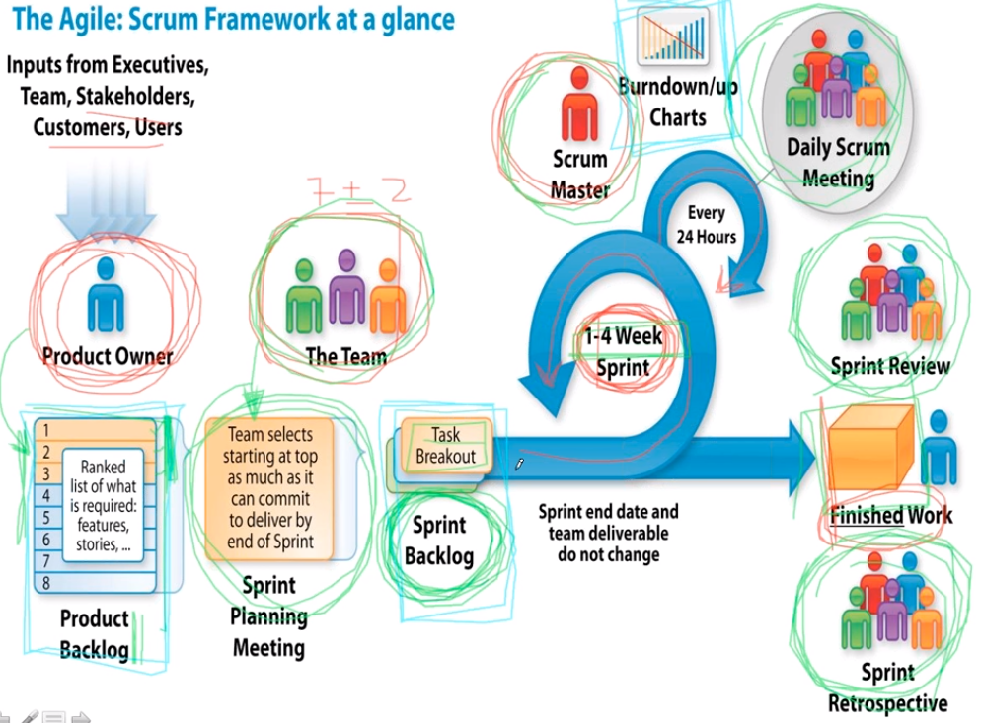

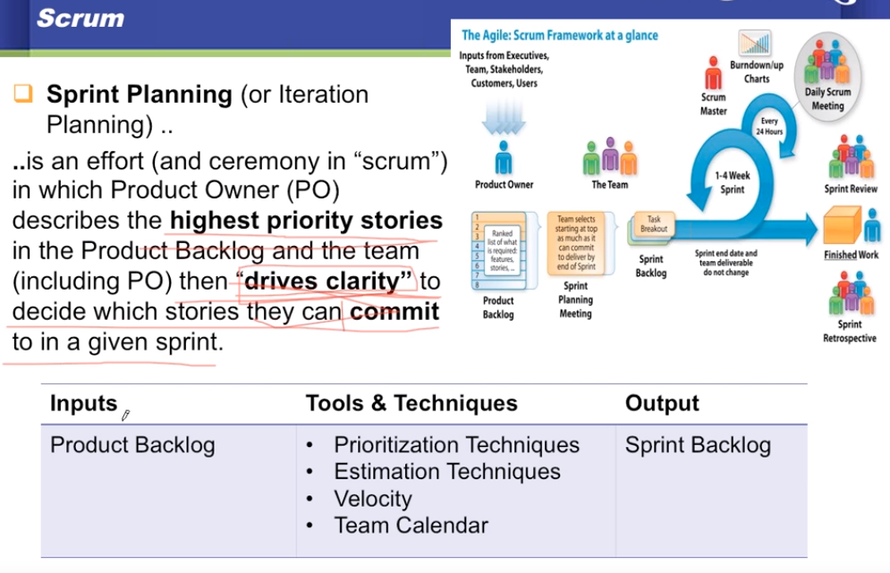

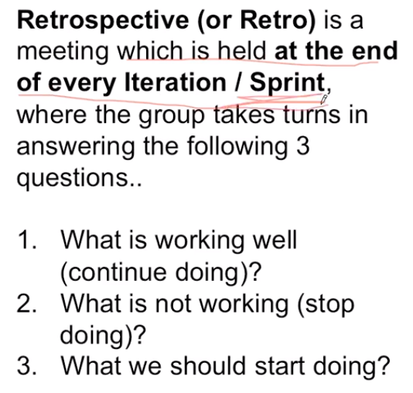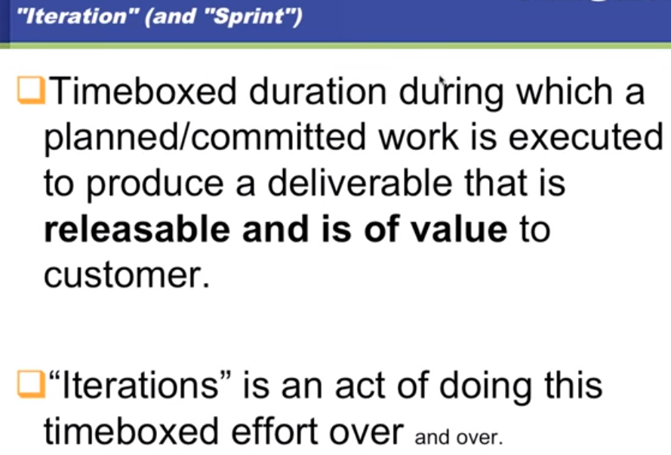

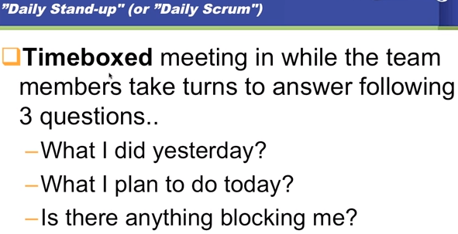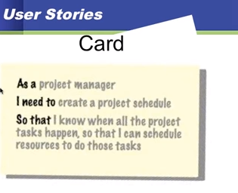

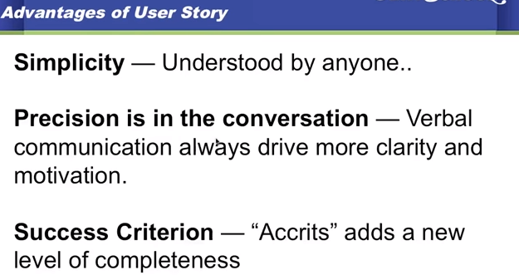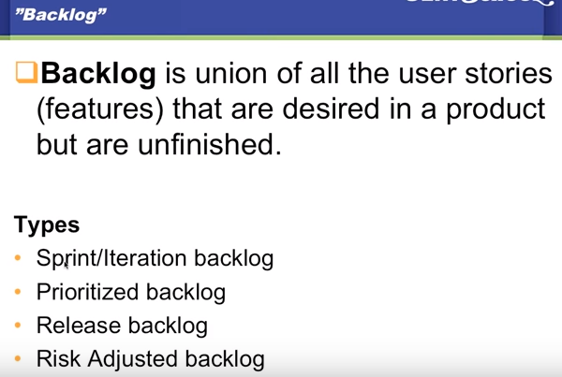

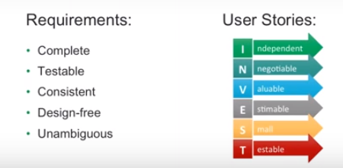

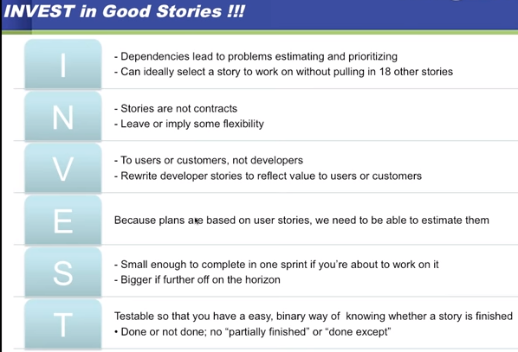

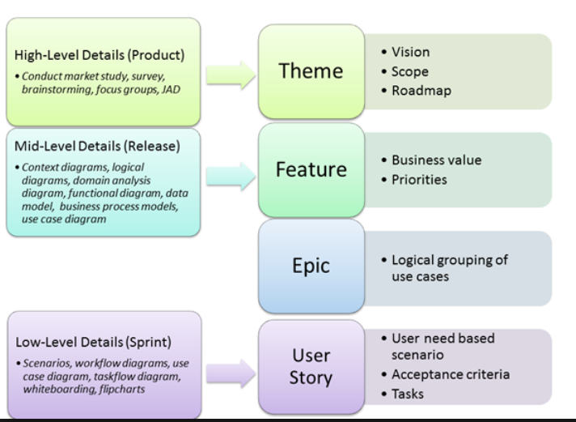

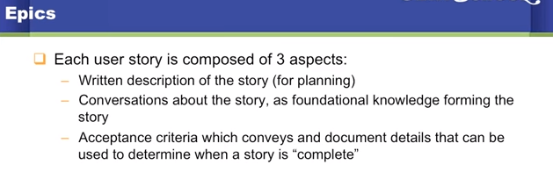

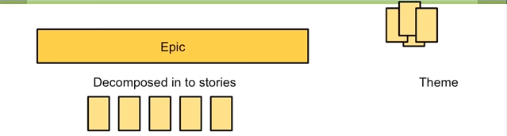

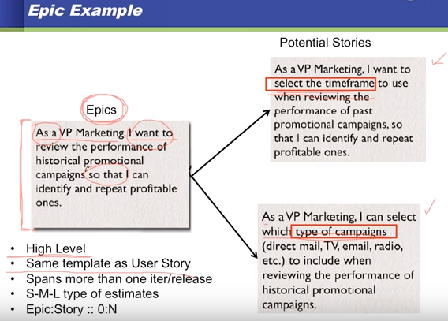

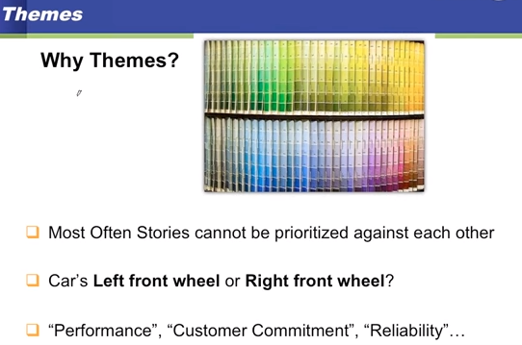

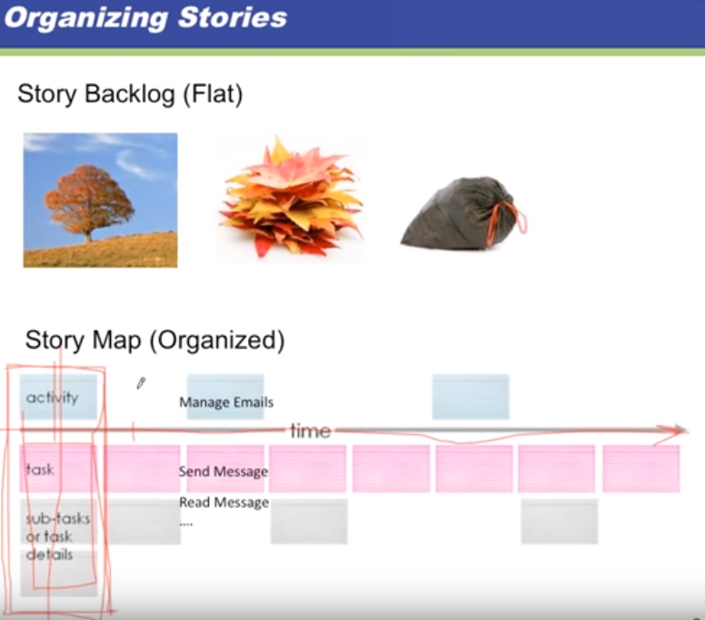

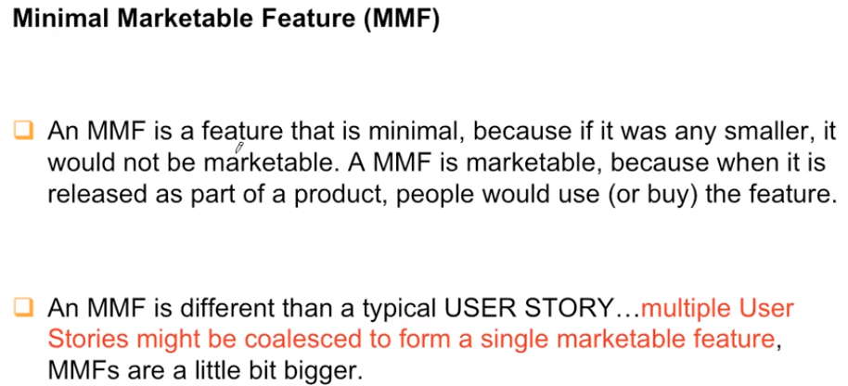

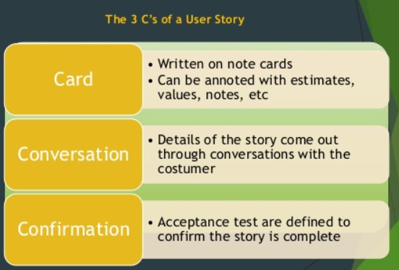

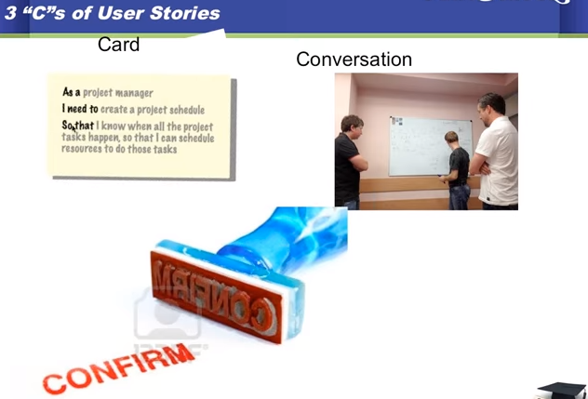

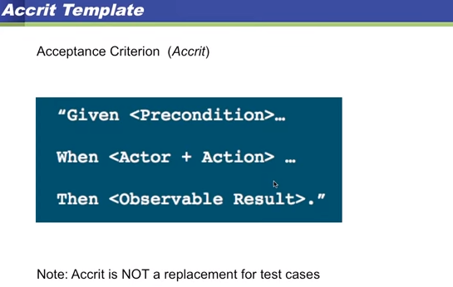

**Example:**

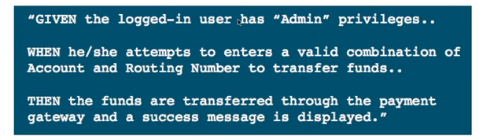

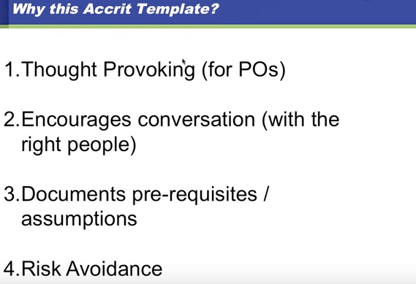

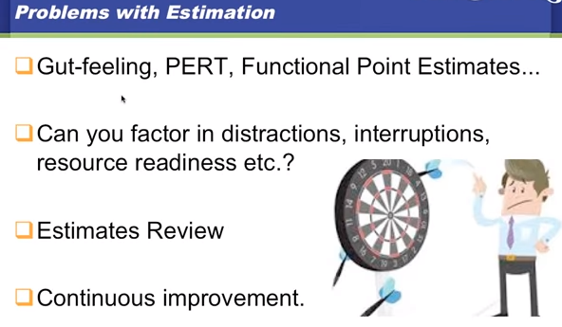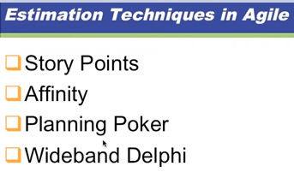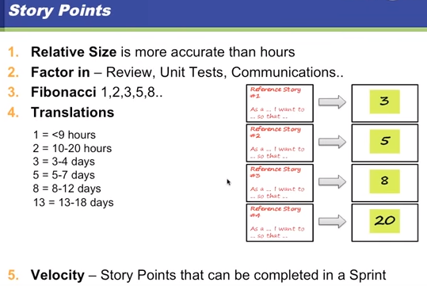

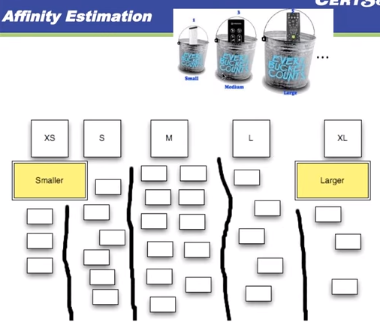

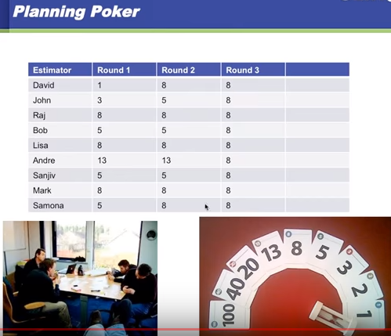

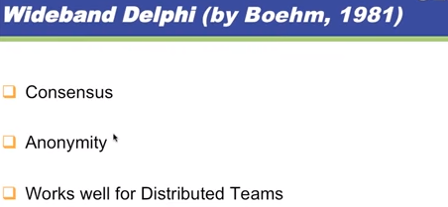

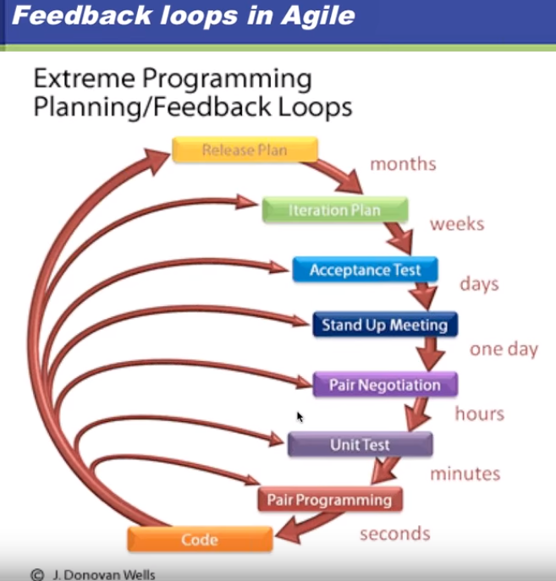

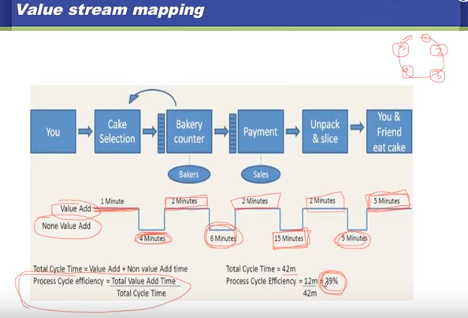

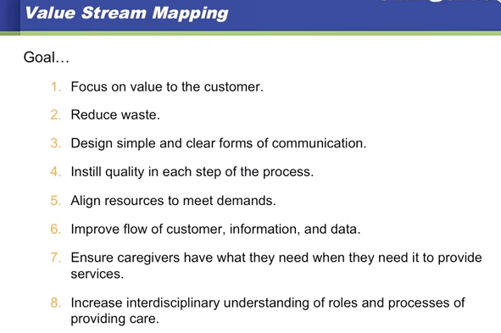

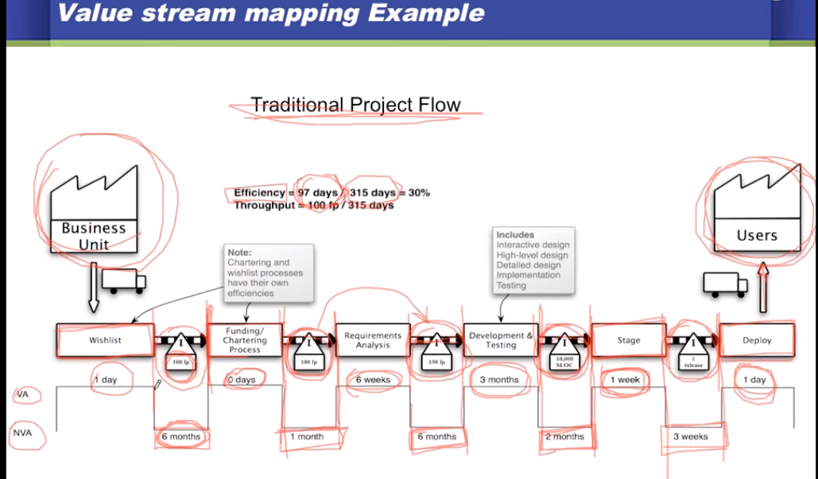

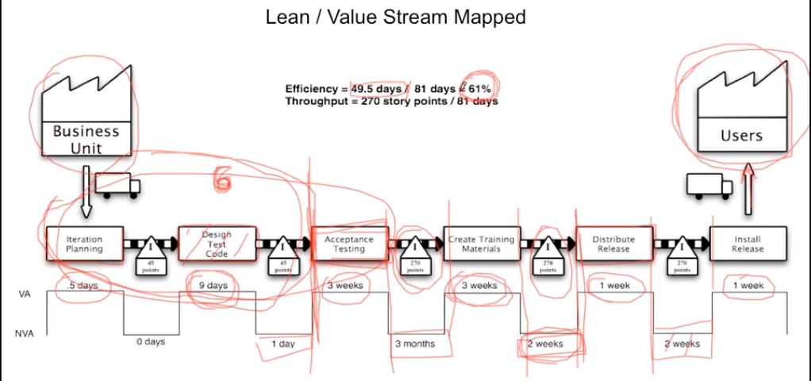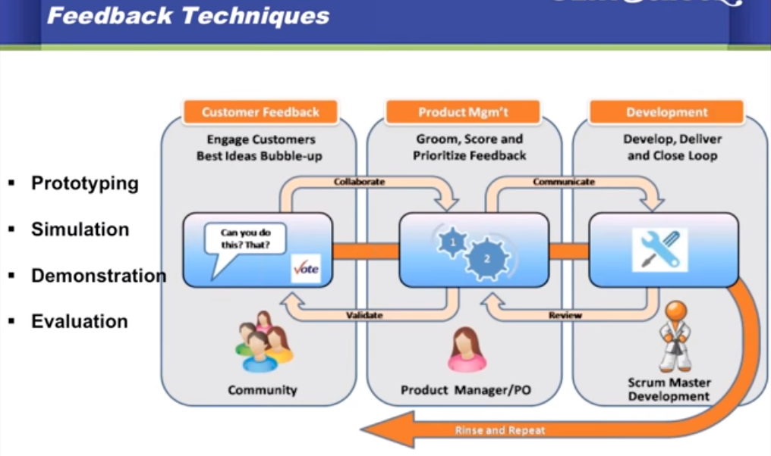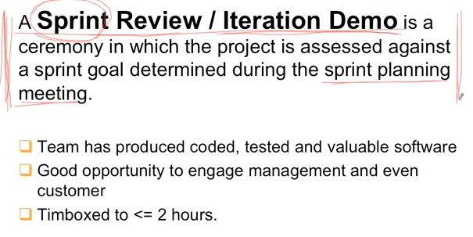

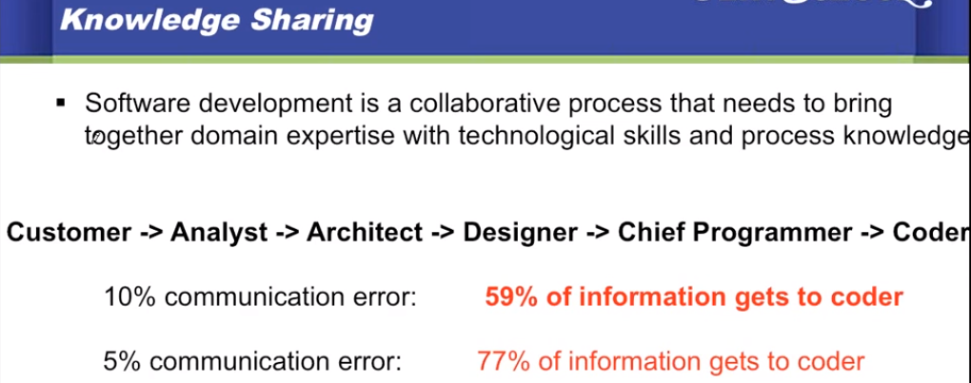

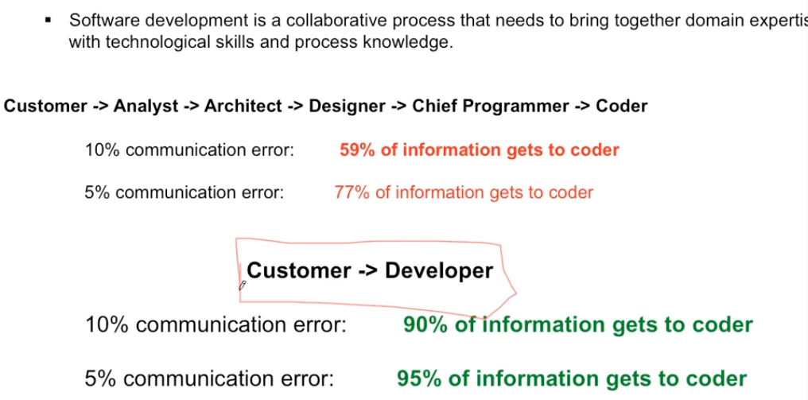

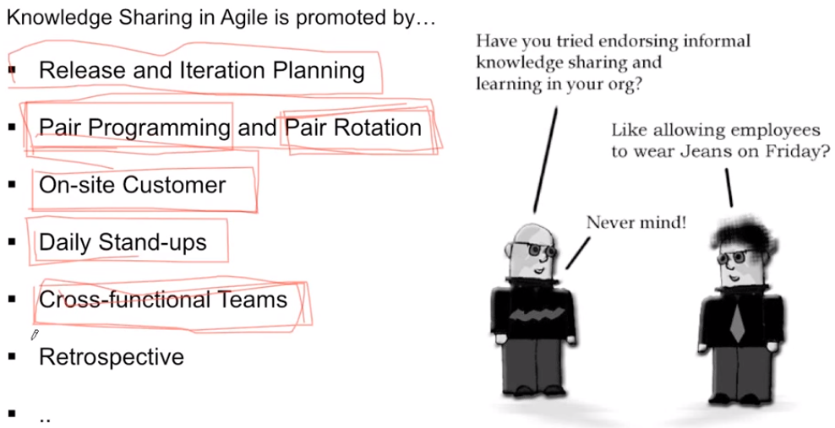

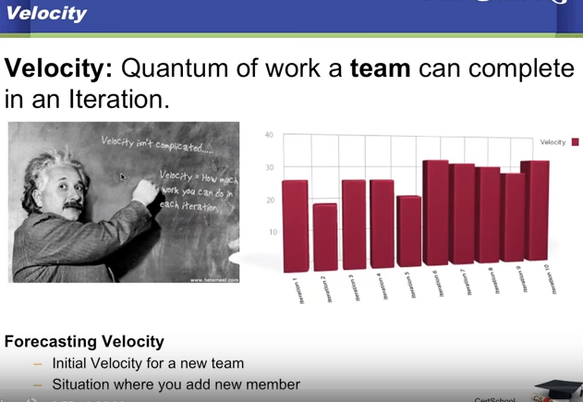

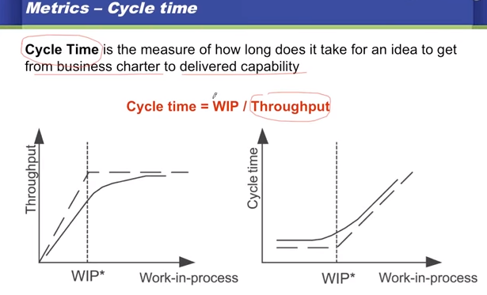

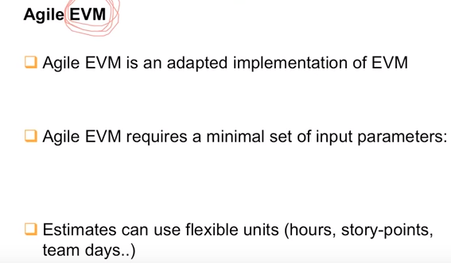

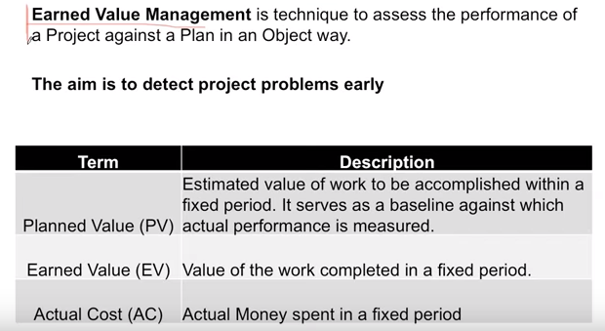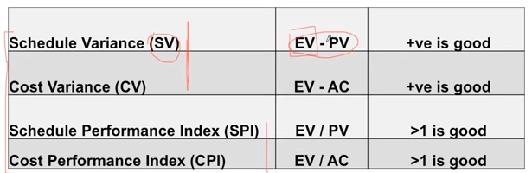

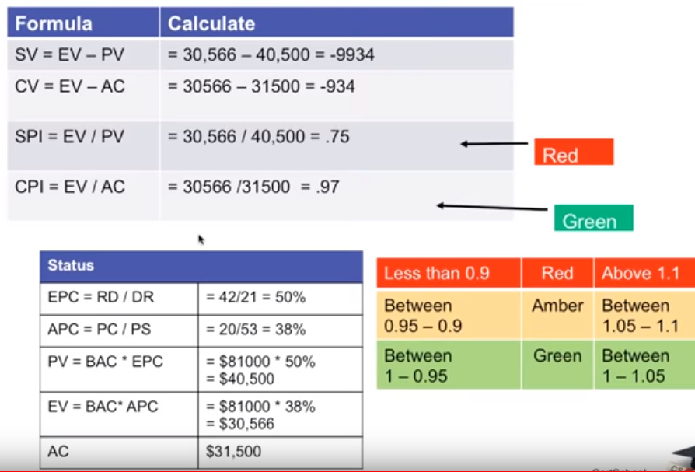

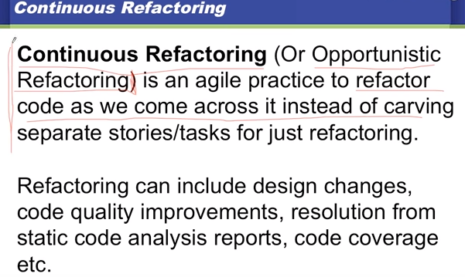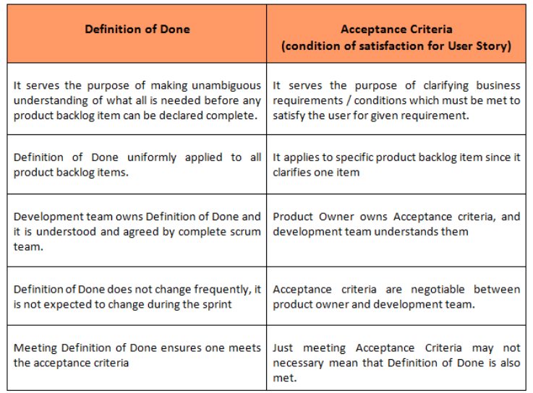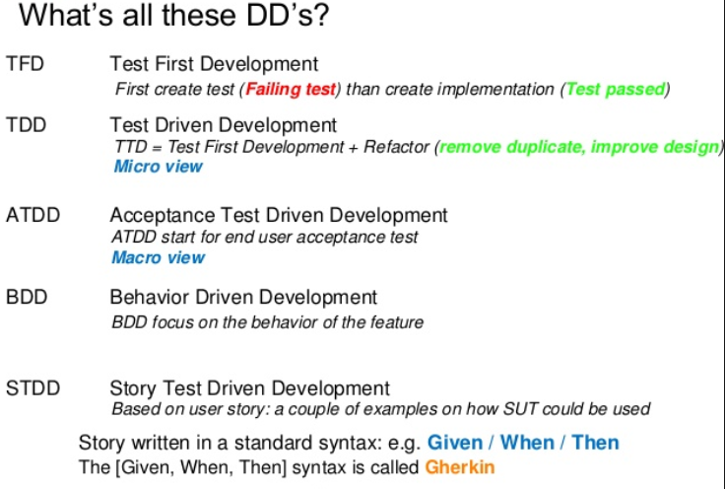

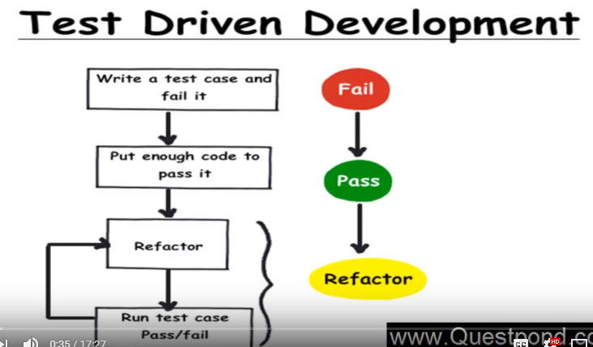

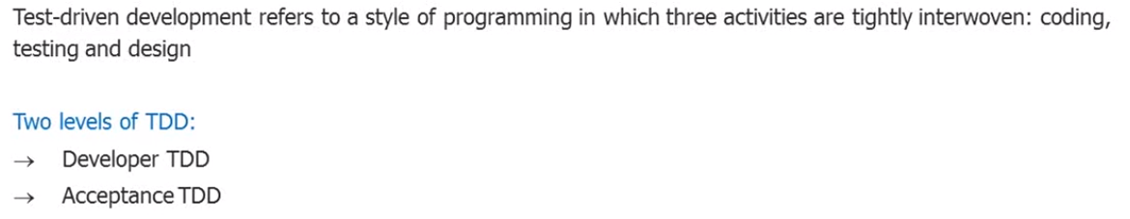

**Advantages of TDD:**

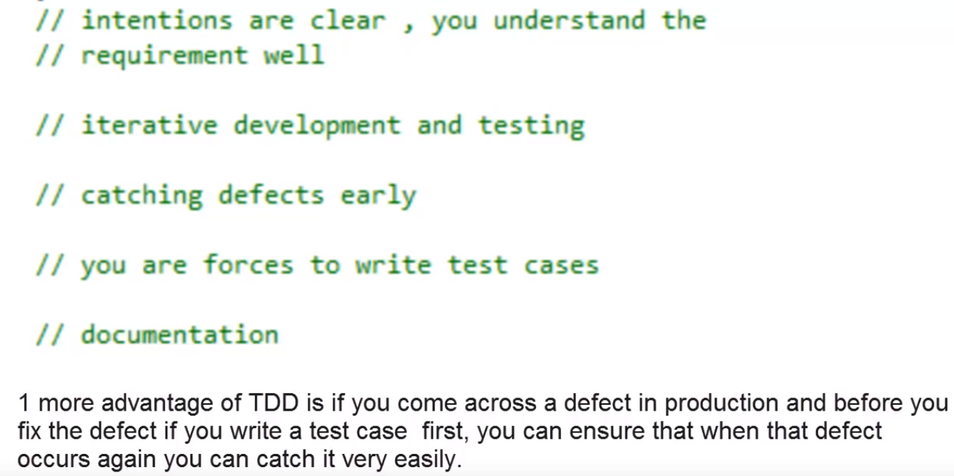

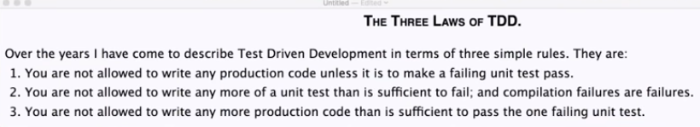

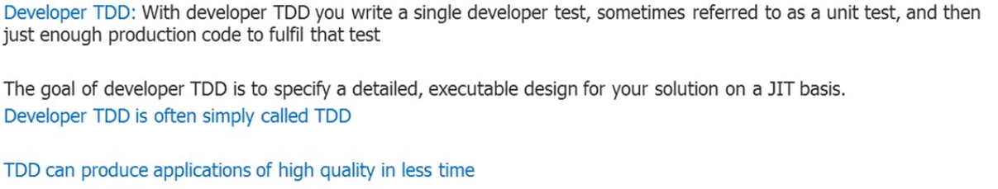

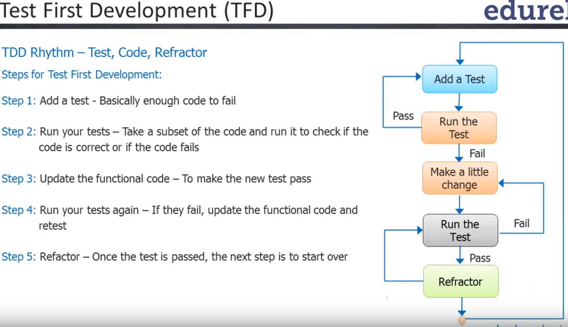

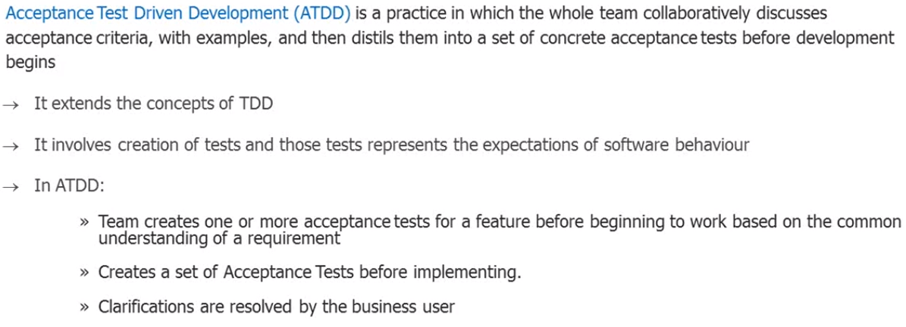

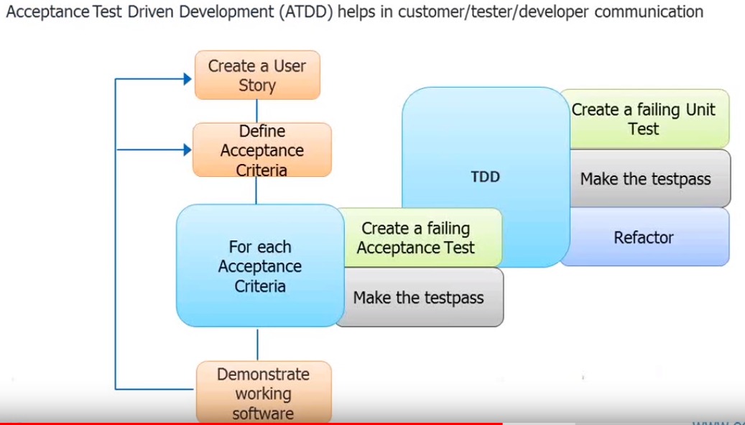

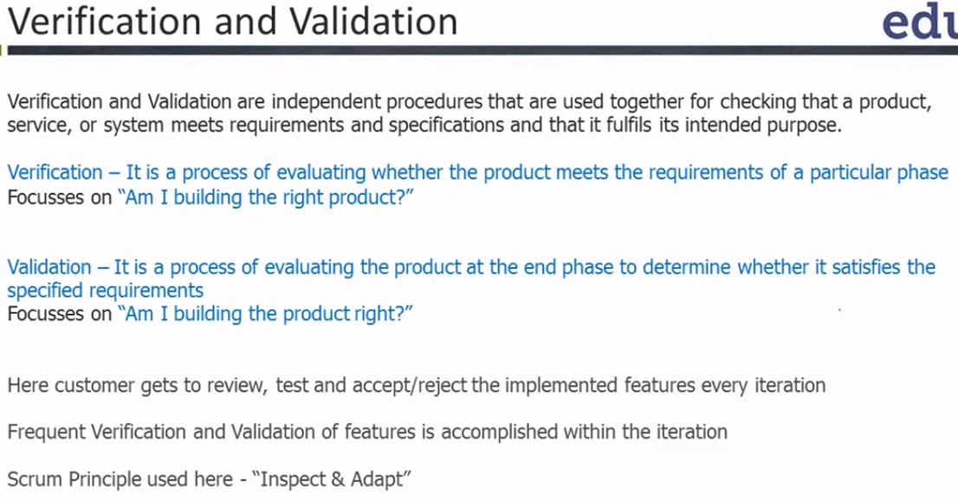

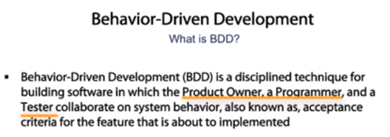

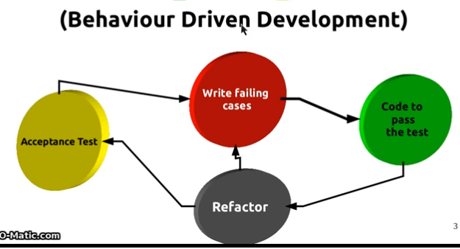

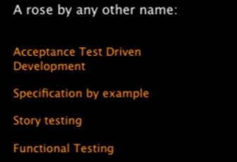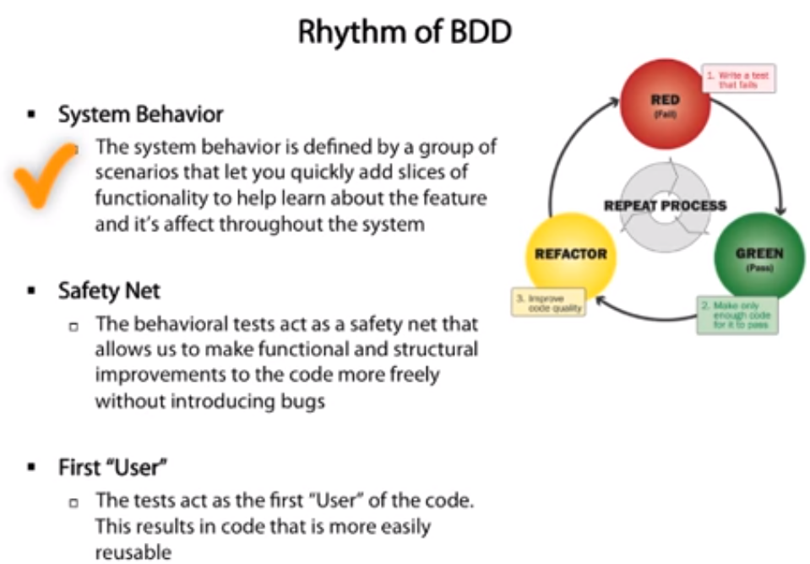

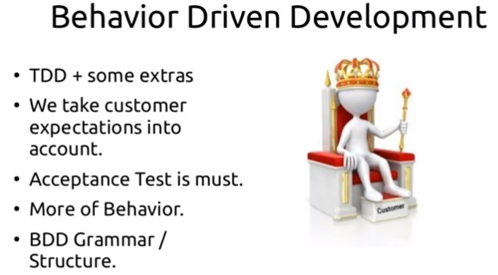

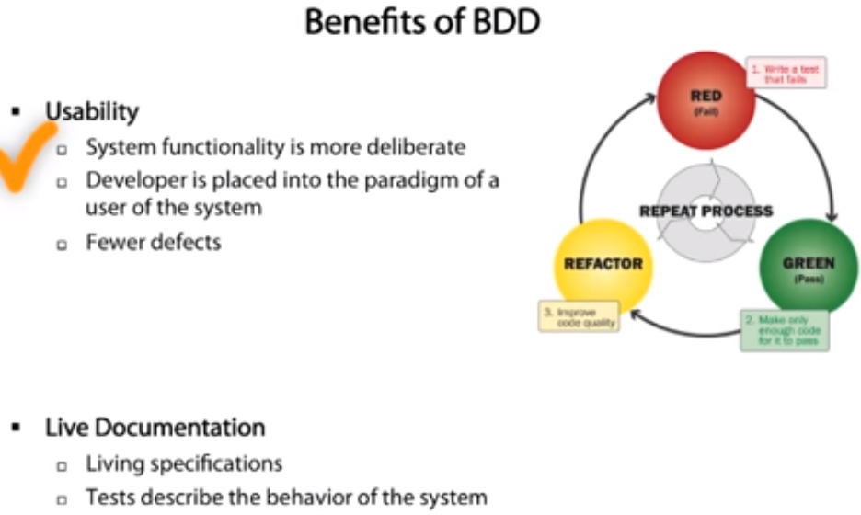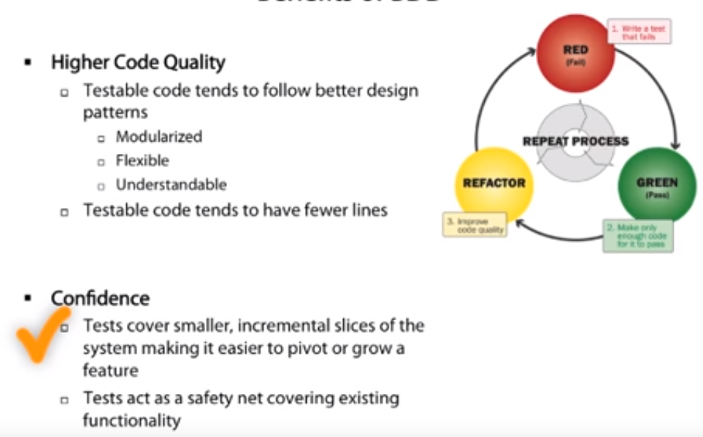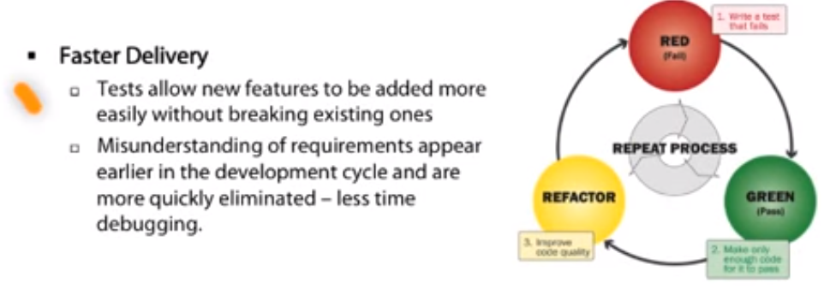

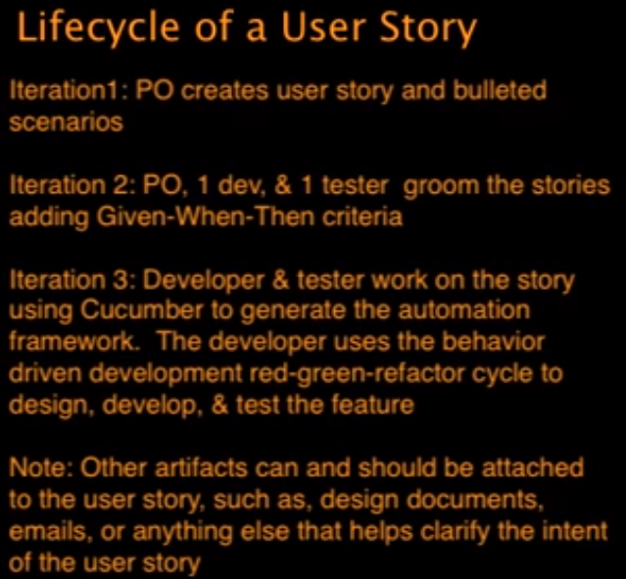

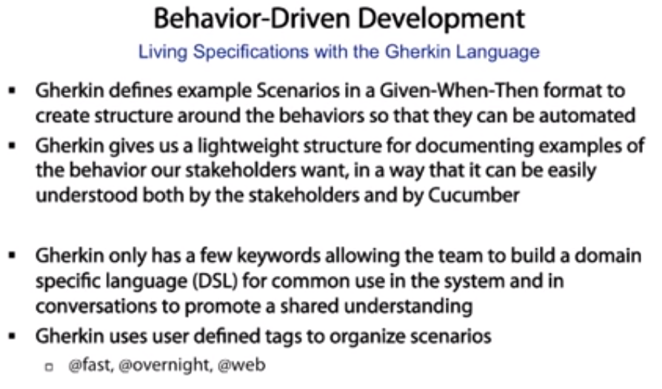

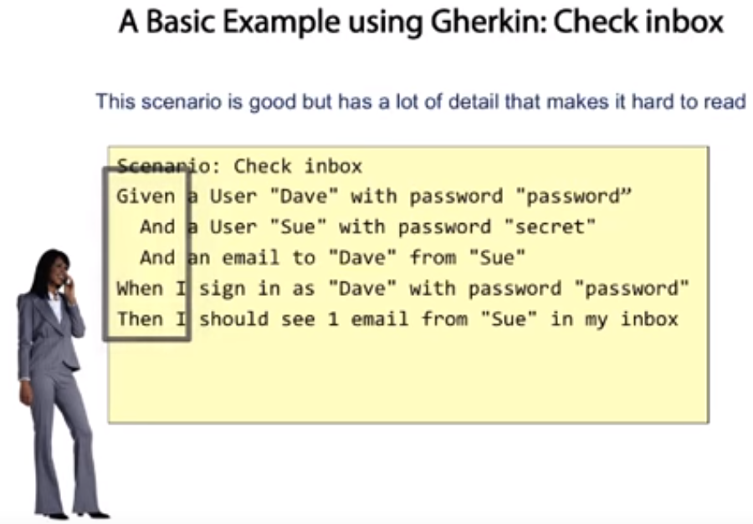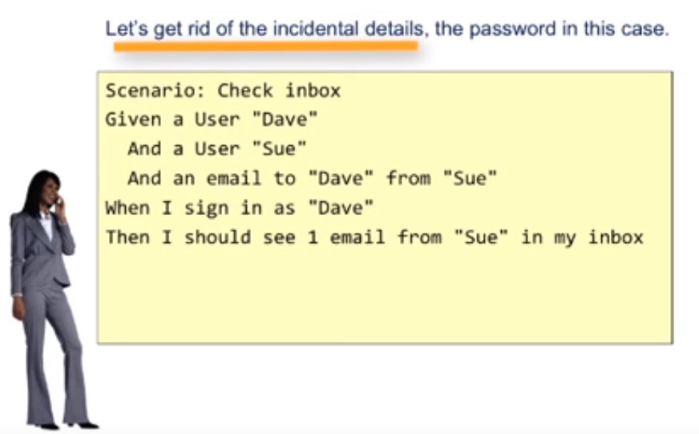

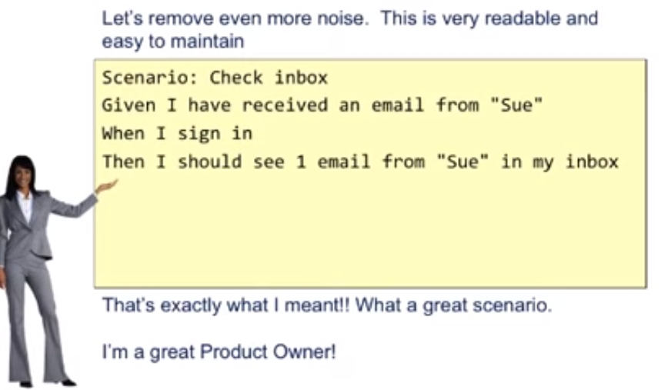

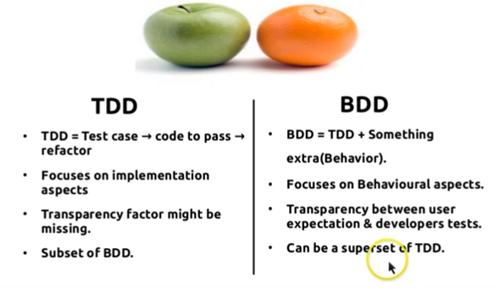

**Spike**. A task aimed at answering a question or gathering information, rather than at producing shippable product. Sometimes a user story is generated that cannot be well estimated until the development team does some actual work to resolve a technical question or a design problem.

Agile **Tracer**. The term **Tracer** is used by the military and gun enthusiasts for specially adapted ammunition called **Tracer Bullets**. **Tracer Bullets** are loaded inside a line of ammunition at regular intervals along with the live ammunition in the ammunition carrier.

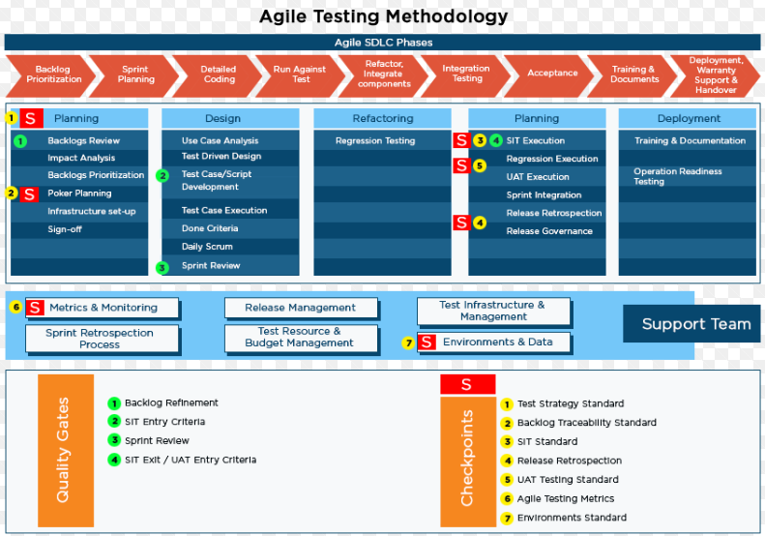

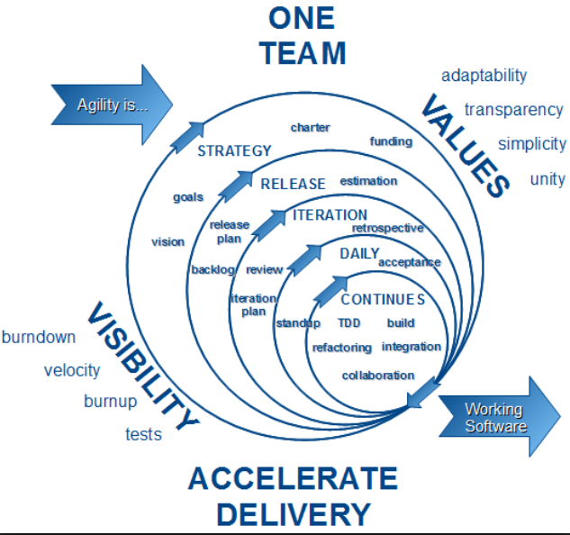

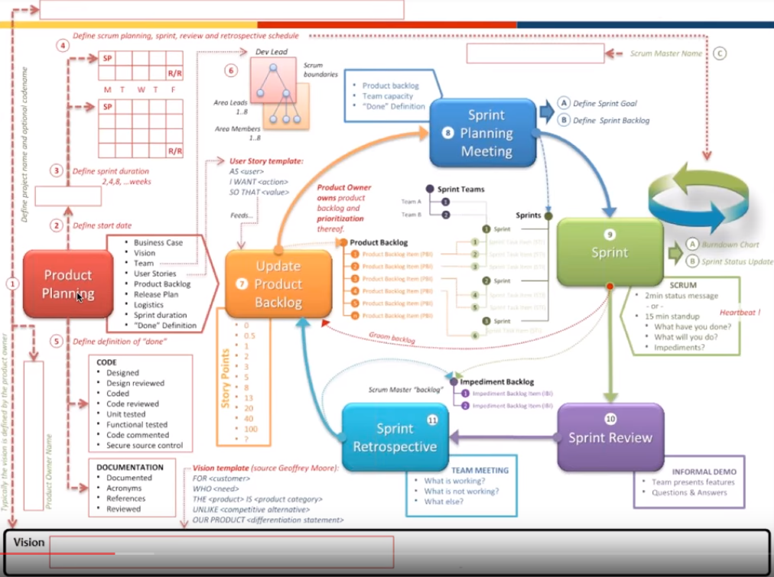

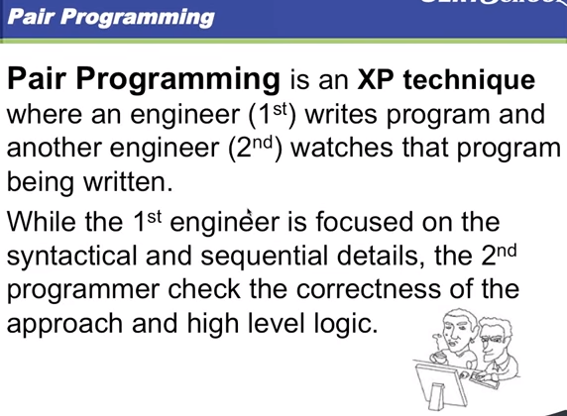

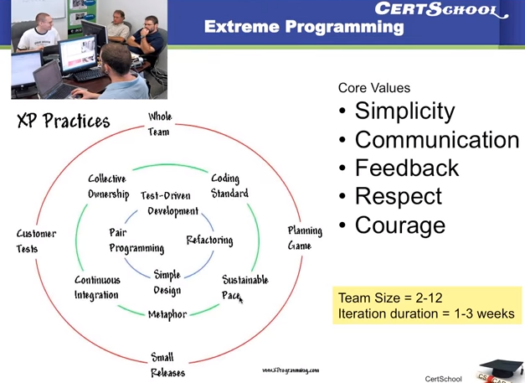

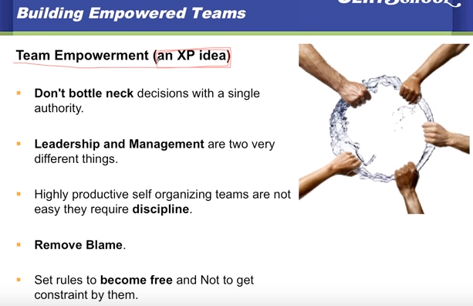

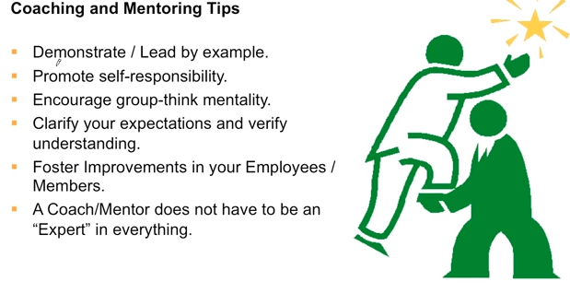

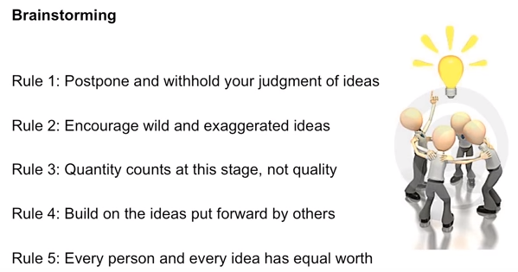

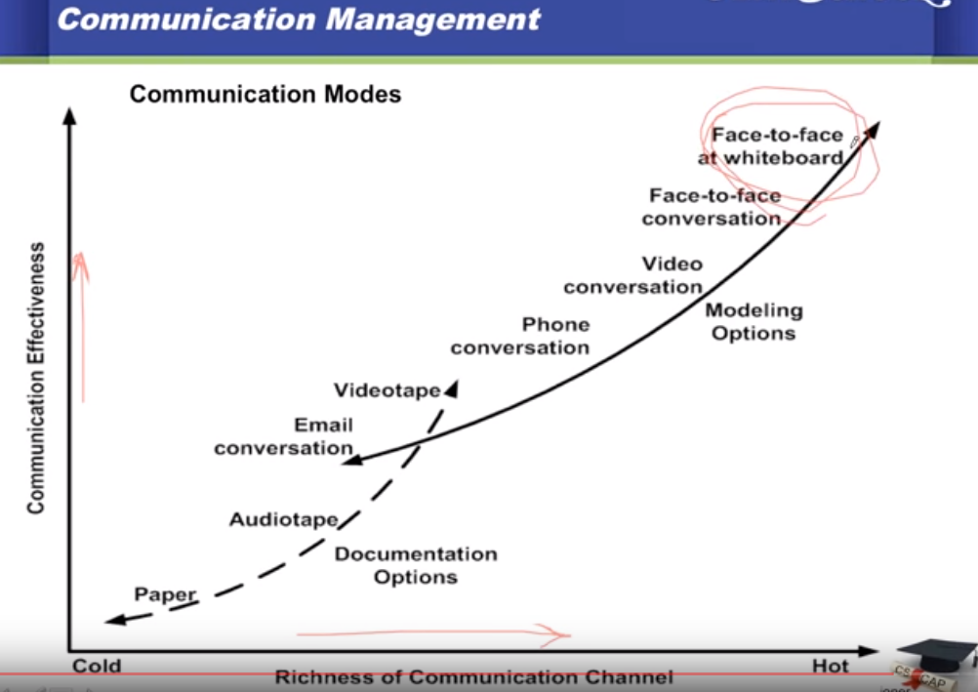

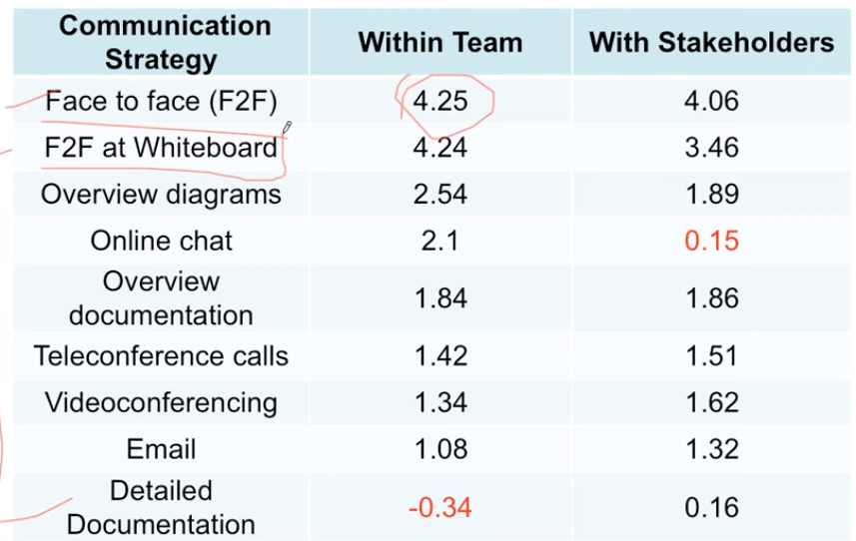

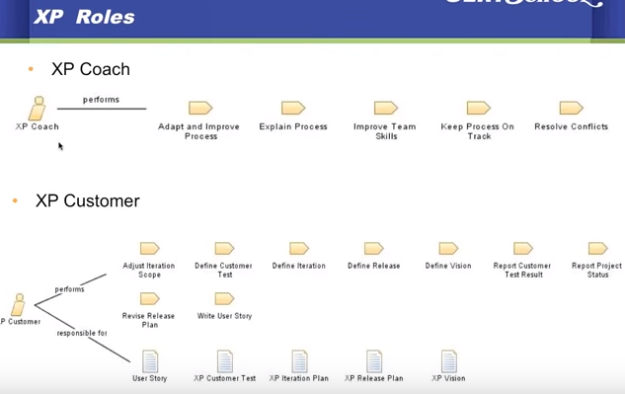

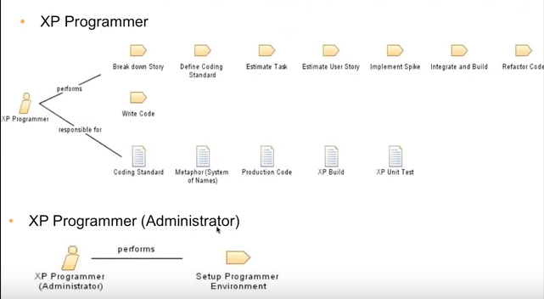

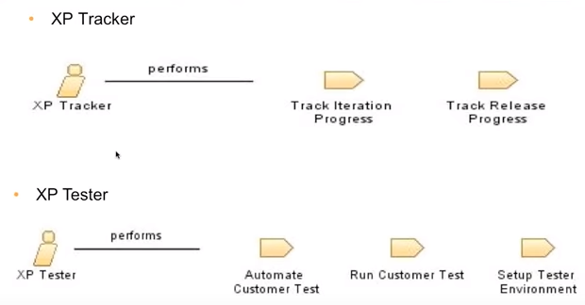

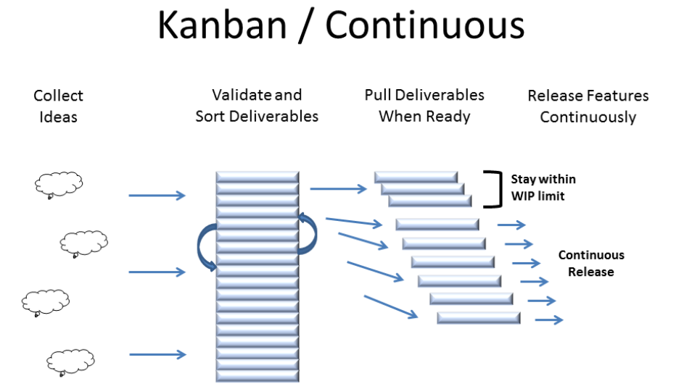

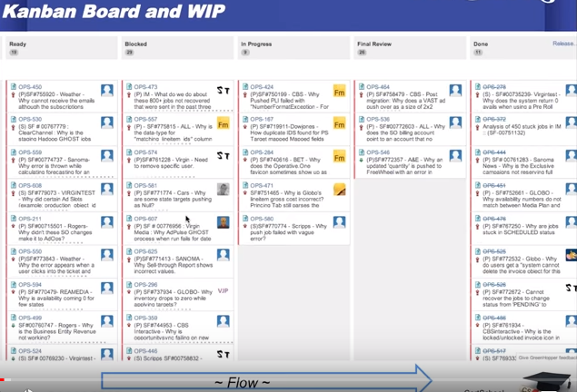

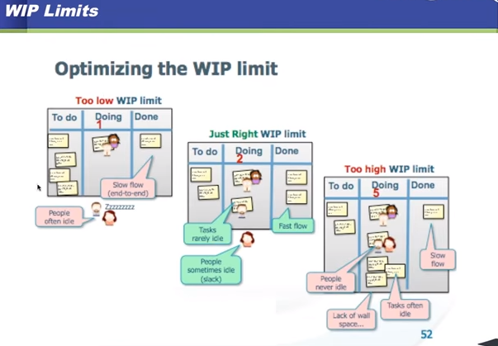

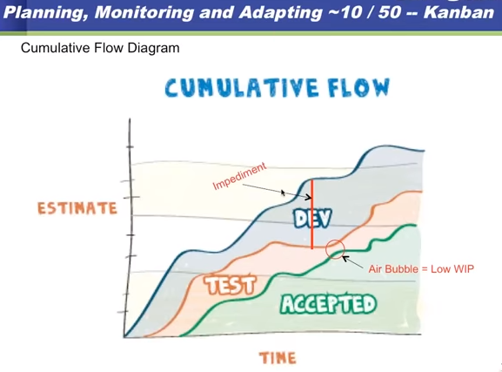

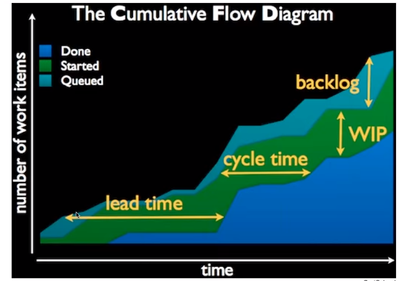

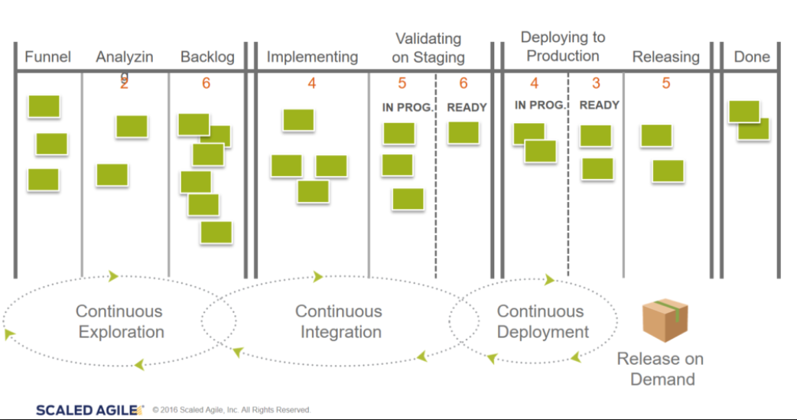

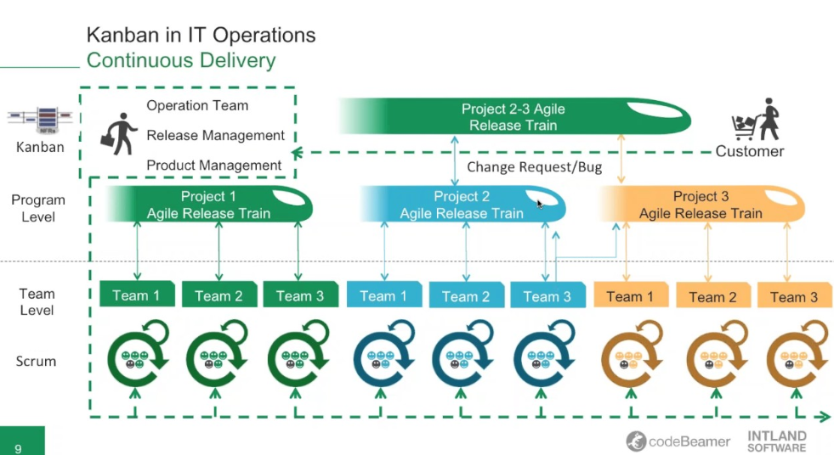

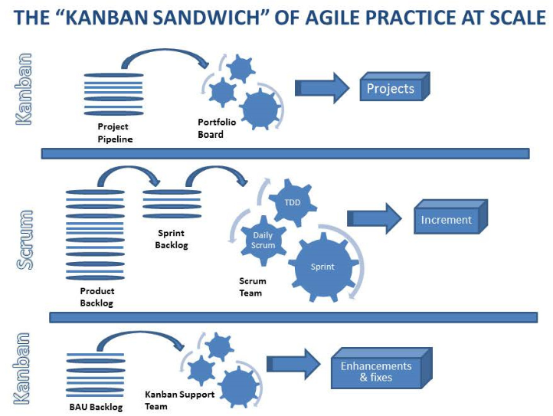

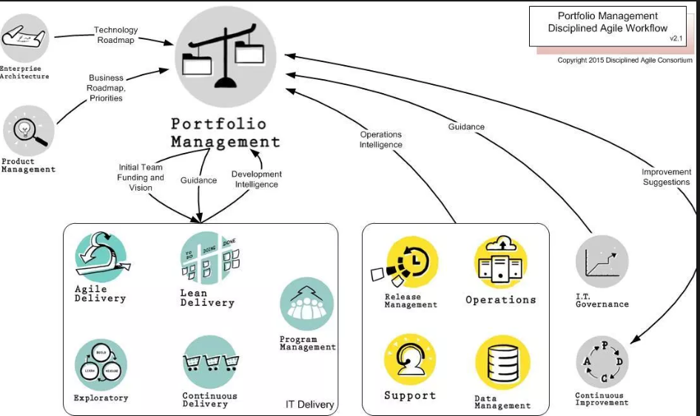

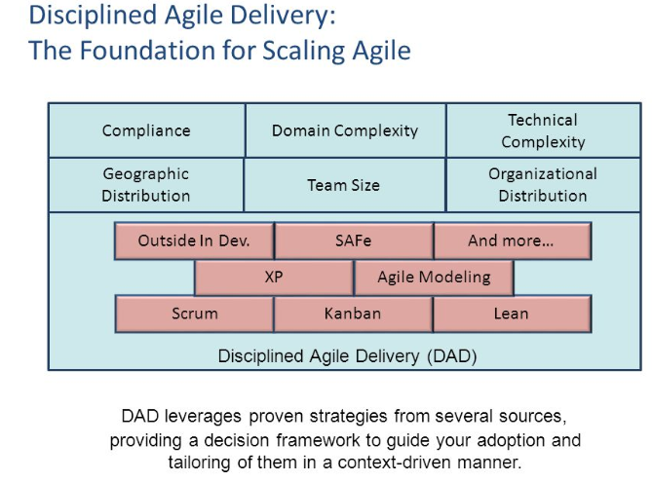

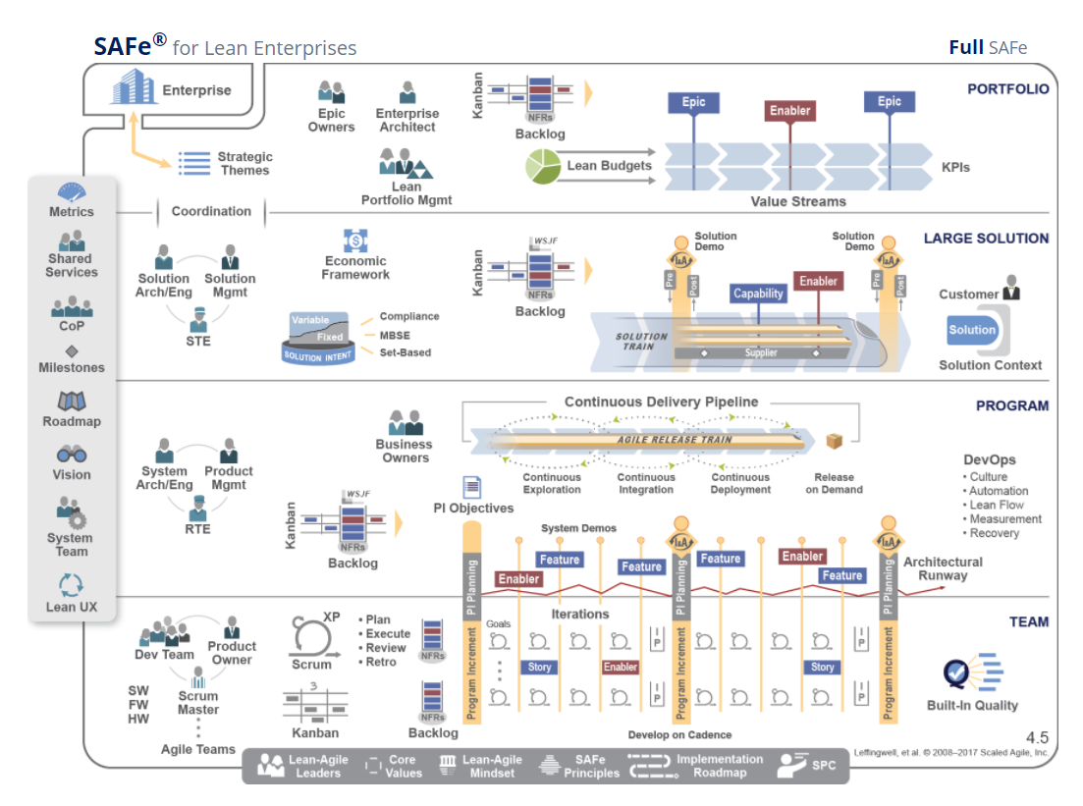

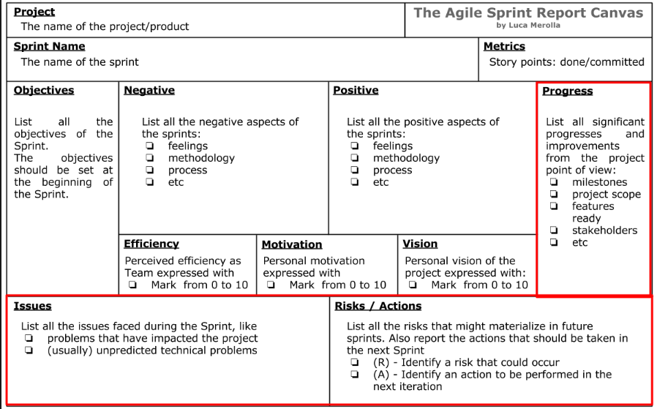

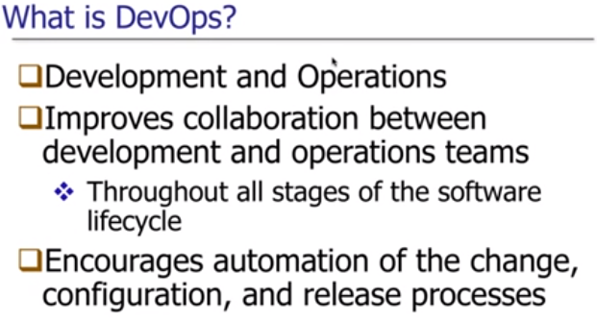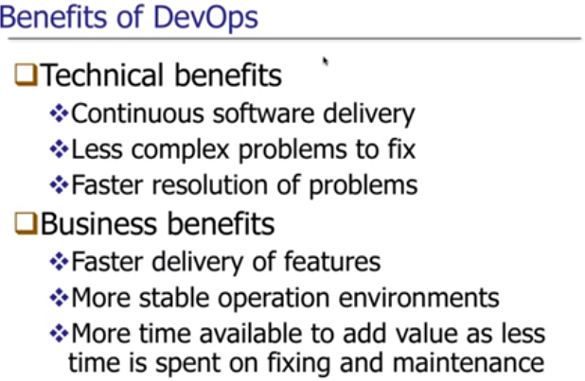

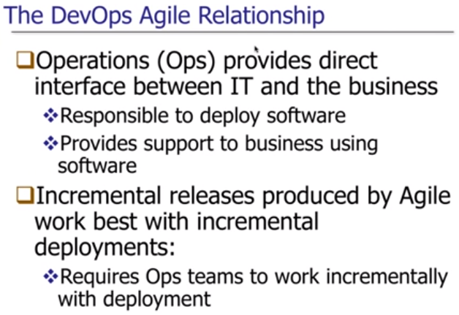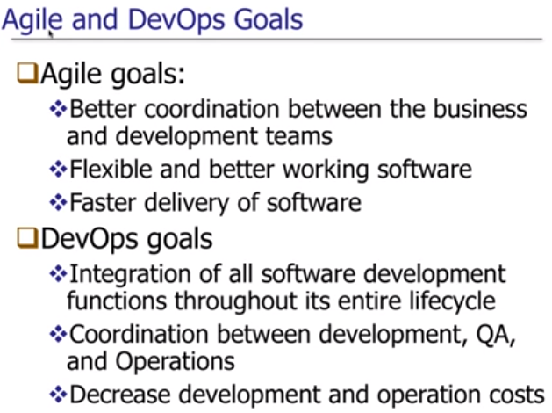

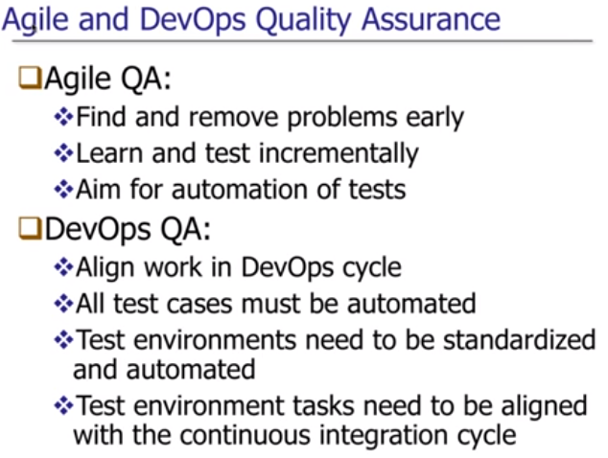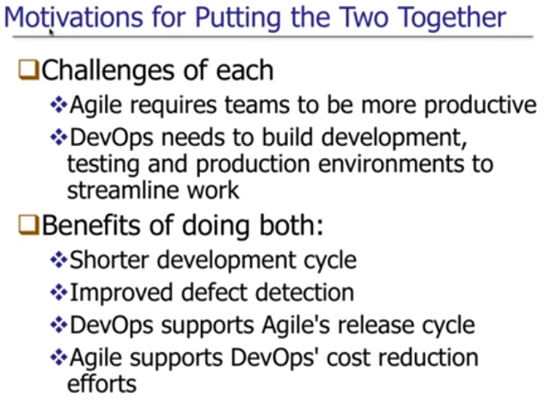

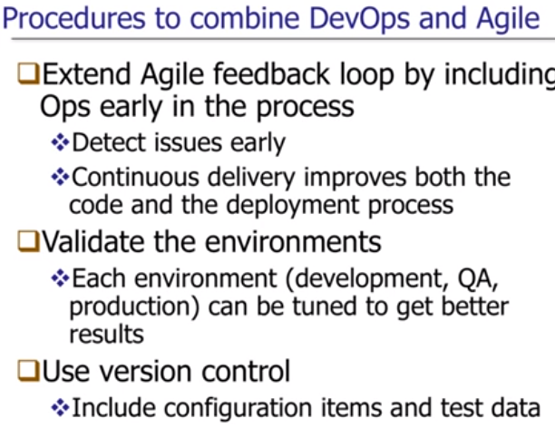 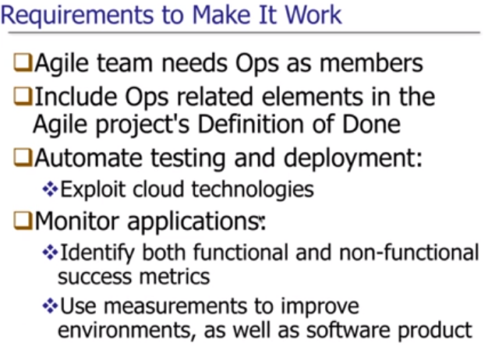

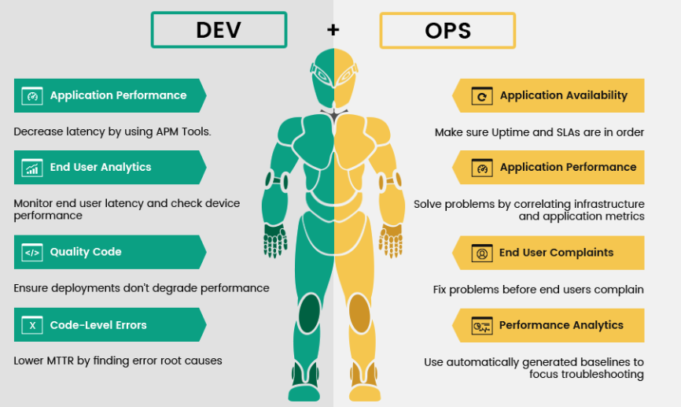

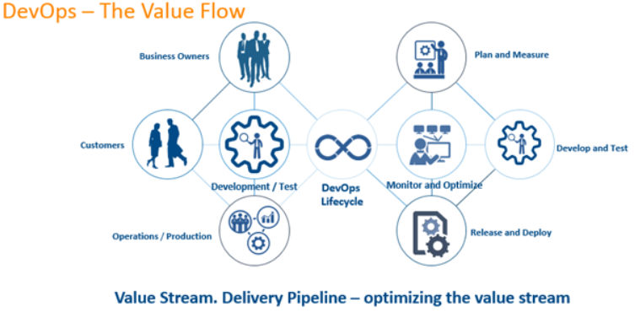

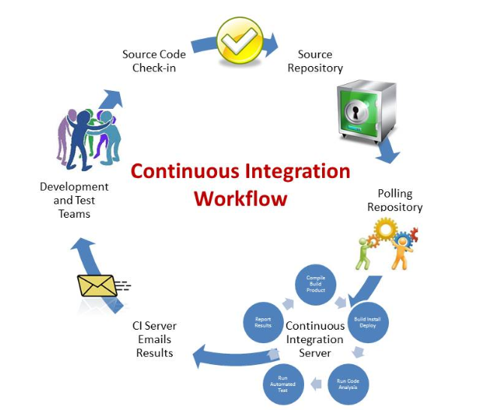

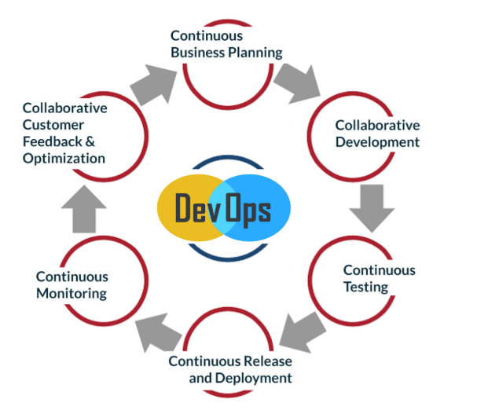

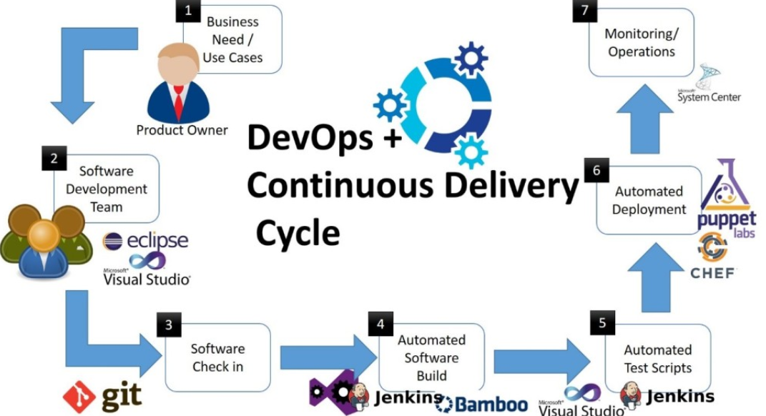

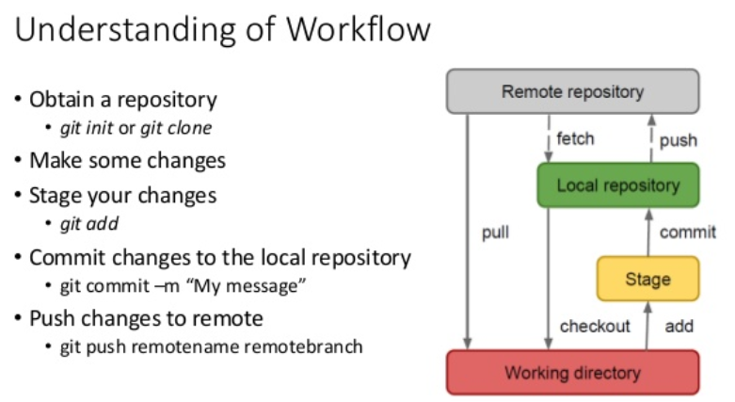

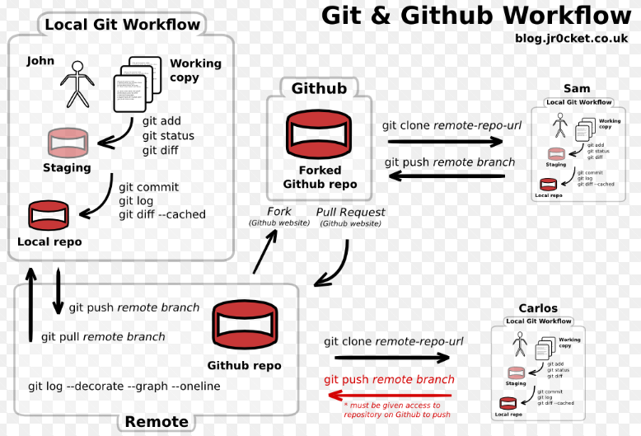

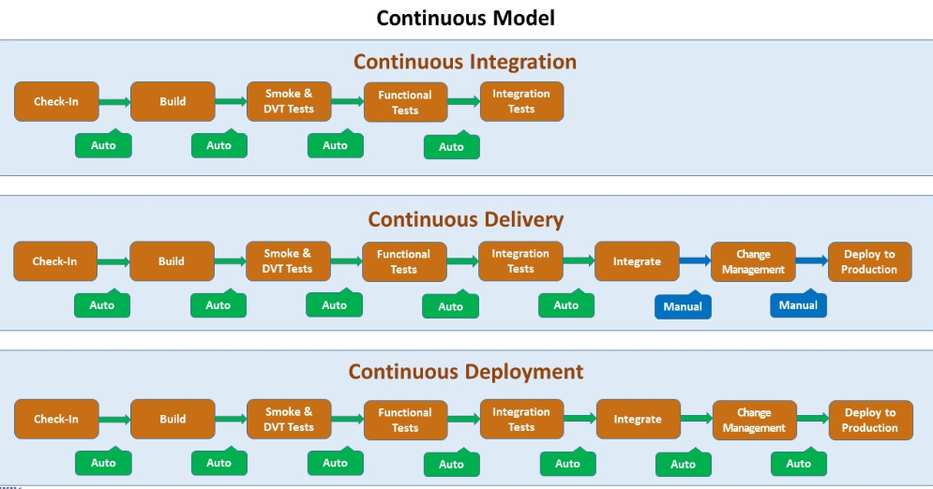

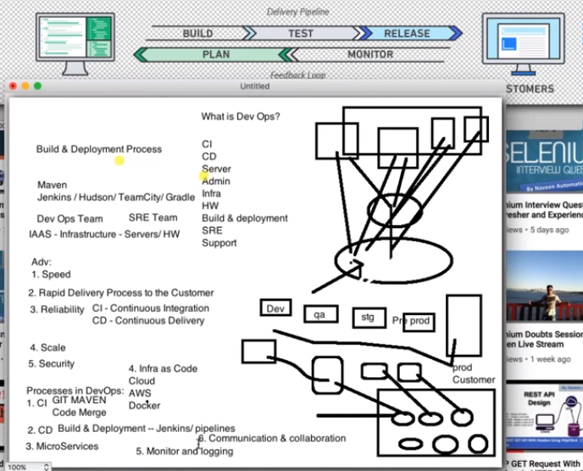

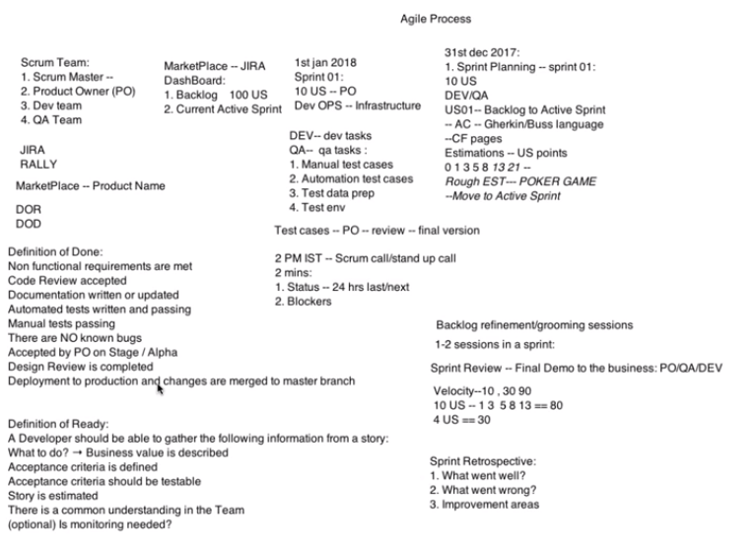

**An Introduction to Continuous Integration, Delivery, and Deployment**

Developing and releasing software can be a complicated process, especially as applications, teams, and deployment infrastructure grow in complexity themselves. Often, challenges become more pronounced as projects grow. To develop, test, and release software in a quick and consistent way, developers and organizations have created three related but distinct strategies to manage and automate these processes.

Continuous integration focuses on integrating work from individual developers into a main repository multiple times a day to catch integration bugs early and accelerate collaborative development. Continuous delivery is concerned with reducing friction in the deployment or release process, automating the steps required to deploy a build so that code can be released safely at any time. Continuous deployment takes this one step further by automatically deploying each time a code change is made.

**What is Continuous Integration and Why Is It Helpful?**

**Continuous integration** is a practice that encourages developers to integrate their code into a main branch of a shared repository early and often. Instead of building out features in isolation and integrating them at the end of a development cycle, code is integrated with the shared repository by each developer multiple times throughout the day.

The idea is to minimize the cost of integration by making it an early consideration. Developers can discover conflicts at the boundaries between new and existing code early, while conflicts are still relatively easy to reconcile. Once the conflict is resolved, work can continue with confidence that the new code honors the requirements of the existing codebase.

Integrating code frequently does not, by itself, offer any guarantees about the quality of the new code or functionality. In many organizations, integration is costly because manual processes are used to ensure that the code meets standards, does not introduce bugs, and does not break existing functionality. Frequent integration can create friction when the level of automation does not match the amount quality assurance measures in place.

To address this friction within the integration process, in practice, continuous integration relies on robust test suites and an automated system to run those tests. When a developer merges code into the main repository, automated processes kick off a build of the new code. Afterwards, test suites are run against the new build to check whether any integration problems were introduced. If either the build or the test phase fails, the team is alerted so that they can work to fix the build.

The end goal of continuous integration is to make integration a simple, repeatable process that is part of the everyday development workflow in order to reduce integration costs and respond to defects early. Working to make sure the system is robust, automated, and fast while cultivating a team culture that encourages frequent iteration and responsiveness to build issues is fundamental to the success of the strategy.

**What is Continuous Delivery and Why Is It Helpful?**

**Continuous delivery** is an extension of continuous integration. It focuses on automating the software delivery process so that teams can easily and confidently deploy their code to production at any time. By ensuring that the codebase is always in a deployable state, releasing software becomes an unremarkable event without complicated ritual. Teams can be confident that they can release whenever they need to without complex coordination or late-stage testing. As with continuous integration, continuous delivery is a practice that requires a mixture of technical and organizational improvements to be effective.

On the technology side, continuous delivery leans heavily on deployment pipelines to automate the testing and deployment processes. A **deployment pipeline** is an automated system that runs increasingly rigorous test suites against a build as a series of sequential stages. This picks up where continuous integration leaves off, so a reliable continuous integration setup is a prerequisite to implementing continuous delivery.

At each stage, the build either fails the tests, which alerts the team, or passes the tests, which results in automatic promotion to the next stage. As the build moves through the pipeline, later stages deploy the build to environments that mirror the production environment as closely as possible. This way the build, the deployment process, and the environment can be tested in tandem. The pipeline ends with a build that can be deployed to production at any time in a single step.

The organizational aspects of continuous delivery encourage prioritization of "deployability" as a principle concern. This has an impact on the way that features are built and hooked into the rest of the codebase. Thought must be put into the design of the code so that features can be safely deployed to production at any time, even when incomplete. A [number of techniques](https://www.digitalocean.com/community/tutorials/an-introduction-to-continuous-integration-delivery-and-deployment#additional-terminology) have emerged to assist in this area.

Continuous delivery is attractive because it automates the steps between checking code into the repository and deciding on whether to release well-tested, functional builds to your production infrastructure. The steps that help assert the quality and correctness of the code are automated, but the final decision about what to release is left in the hands of the organization for maximum flexibility.

**What is Continuous Deployment and Why Is It Helpful?**

**Continuous deployment** is an extension of continuous delivery that automatically deploys each build that passes the full test cycle. Instead of waiting for a human gatekeeper to decide what and when to deploy to production, a continuous deployment system deploys everything that has successfully traversed the deployment pipeline. Keep in mind that while new code is automatically deployed, techniques exist to activate new features at a later time or for a subset of users. Deploying automatically pushes features and fixes to customers quickly, encourages smaller changes with limited scope, and helps avoid confusion over what is currently deployed to production.

This fully automated deploy cycle can be a source of anxiety for organizations worried about relinquishing control to their automation system of what gets released. The trade-off offered by automated deployments is sometimes judged to be too dangerous for the payoff they provide.

Other groups leverage the promise of automatic release as a method of ensuring that best practices are always followed and to extend the testing process into a limited production environment. Without a final manual verification before deploying a piece of code, developers must take responsibility for ensuring that their code is well-designed and that the test suites are up-to-date. This collapses the decision of what and when to commit to the main repository and what and when to release to production into a single point that exists firmly in the hands of the development team.

Continuous deployment also allows organizations to benefit from consistent early feedback. Features can immediately be made available to users and defects or unhelpful implementations can be caught early before the team devotes extensive effort in an unproductive direction. Getting fast feedback that a feature isn't helpful lets the team shift focus rather than sinking more energy into an area with minimal impact.

## Key Concepts and Practices for Continuous Processes

While continuous integration, delivery, and deployment vary in the scope of their involvement, there are some concepts and practices that are fundamental to the success of each.

**Small, Iterative Changes**

One of the most important practices when adopting continuous integration is to encourage small changes. Developers should practice breaking up larger work into small pieces and committing those early. Special techniques like branch by abstraction and feature flags (see below) help to protect the functionality of the main branch from in-progress code changes.

Small changes minimize the possibility and impact of integration problems. By committing to the shared branch at the earliest possible stage and then continually throughout development, the cost of integration is diminished and unrelated work is synchronized regularly.

**Trunk-Based Development**

With trunk-based development, work is done in the main branch of the repository or merged back into the shared repository at frequent intervals. Short-lived feature branches are permissible as long as they represent small changes and are merged back as soon as possible.

The idea behind trunk-based development is to avoid large commits that violate of concept of small, iterative changes discussed above. Code is available to peers early so that conflicts can be resolved when their scope is small.

Releases are performed from the main branch or from a release branch created from the trunk specifically for that purpose. No development occurs on the release branches in order to maintain focus on the main branch as the single source of truth.

**Keep the Building and Testing Phases Fast**

Each of the processes relies on automated building and testing to validate correctness. Because the build and test steps must be performed frequently, it is essential that these processes be streamlined to minimize the time spent on these steps.

Increases in build time should be treated as a major problem because the impact is compounded by the fact that each commit kicks off a build. Because continuous processes force developers to engage with these activities daily, reducing friction in these areas is a worthwhile pursuit.

When possible, running different sections of the test suite in parallel can help move the build through the pipeline faster. Care should also be taken to make sure the proportion of each type of test makes sense. Unit tests are typically very fast and have minimal maintenance overhead. In contrast, automated system or acceptance testing is often complex and prone to breakage. To account for this, it is often a good idea to rely heavily on unit tests, conduct a fair number of integration tests, and then back off on the number of later, more complex testing.

**Consistency Throughout the Deployment Pipeline**

Because a continuous delivery or deployment implementations is supposed to be testing release worthiness, it is essential to maintain consistency during each step of the process—the build itself, the deployment environments, and the deployment process itself:

* **Code should be built once at the beginning of the pipeline**: The resulting software should be stored and accessible to later processes without rebuilding. By using the exact same artifact in each phase, you can be certain that you are not introducing inconsistencies as a result of different build tools.
* **Deployment environments should be consistent**: A configuration management system can control the various environments, and environmental changes can be put through the deployment pipeline itself to ensure correctness and consistency. Clean deployment environments should be provisioned each test cycle to prevent legacy conditions from compromising the integrity of the tests. The staging environments should match the production environment as closely as possible to reduce unknown factors present when the build is promoted.
* **Consistent processes should be used to deploy the build in each environment**: Each deployment should be automated and each deployment should use the same centralized tools and procedures. Ad-hoc deployments should be eliminated in favor of deploying only with the pipeline tools.

**Decouple Deployment and Release**

Separating the deployment of code from its release to users is an extremely powerful part of continuous delivery and deployment. Code can be deployed to production without initially activating it or making it accessible to users. Then, the organization decides when to release new functionality or features independent from deployment.

This gives organizations a great deal of flexibility by separating business decisions from technical processes. If the code is already on the servers, then deployment is no longer a delicate part of the release process, which minimizes the number of individuals and the amount of work involved at the time of release.

There are a number of techniques that help teams deploy the code responsible for a feature without releasing it. Feature flags set up conditional logic to check whether to run code based on the value of an environmental variable. Branch by abstraction allows developers to replace implementations by placing an abstraction layer between resource consumers and providers. Careful planning to incorporate these techniques gives you the ability to decouple these two processes.

**Types of Testing**

Continuous integration, delivery, and deployment all rely heavily on automated tests to determine the efficacy and correctness of each code change. Different types of tests are needed throughout these processes to gain confidence in a given solution.

While the categories below in no way represent an exhaustive list, and although there is disagreement on the exact definition of each type, these broad categories of tests represent a variety of ways to evaluate code in different contexts.

**Smoke Testing**

Smoke tests are a special kind of initial checks designed to ensure very basic functionality as well as some basic implementation and environmental assumptions. Smoke tests are generally run at the very start of each testing cycle as a sanity check before running a more complete test suite.

The idea behind this type of test is to help to catch big red flags in an implementation and to bring attention to problems that might indicate that further testing is either not possible or not worthwhile. Smoke tests are not very extensive, but should be extremely quick. If a change fails a smoke test, its an early signal that core assertions were broken and that you should not devote any more time to testing until the problem is resolved.

Context-specific smoke tests can be employed at the start of any new phase testing to assert that the basic assumptions and requirements are met. For instance, smoke tests can be used both prior to integration testing or deploying to staging servers, but the conditions to be tested will vary in each case.

**Unit Testing**

Unit tests are responsible for testing individual elements of code in an isolated and highly targeted way. The functionality of individual functions and classes are tested on their own. Any external dependencies are replaced with stub or mock implementations to focus the test completely on the code in question.

Unit tests are essential to test the correctness of individual code components for internal consistency and correctness before they are placed in more complex contexts. The limited extent of the tests and the removal of dependencies makes it easier to hunt down the cause of any defects. It also is the best time to test a variety of inputs and code branches that might be difficult to hit later on. Often, after any smoke tests, unit tests are the first tests that are run when any changes are made.

Unit tests are typically run by individual developers on their own work station prior to submitting changes. However, continuous integration servers almost always run these tests again as a safe guard before beginning integration tests.

**Integration Testing**

After unit tests, integration testing is performed by grouping together components and testing them as an assembly. While unit tests validate the functionality of code in isolation, integration tests ensure that components cooperate when interfacing with one another. This type of testing has the opportunity to catch an entirely different class of bugs that are exposed through interaction between components.

Typically, integration tests are performed automatically when code is checked into a shared repository. A continuous integration server checks out the code, performs any necessary build steps (usually performing a quick smoke test to make sure the build was successful) and then runs unit and integration tests. Modules are hooked together in different combinations and tested.

Integration tests are important for shared work because they protect the health of the project. Changes must prove that they do not break existing functionality and that they interact with other code as expected. A secondary aim of integration testing is to verify that the changes can be deployed into a clean environment. This is frequently the first testing cycle that is performed off of the developer's own machines, so unknown software and environmental dependencies can also be discovered during this process. This is usually also the first time that new code is tested against real external libraries, services, and data.

**System Testing**

Once integration tests are performed, another level of testing called system testing can begin. In many ways, system testing acts as an extension to integration testing. The focus of system tests are to make sure that groups of components function correctly as a cohesive whole.

Instead of focusing on the interfaces between components, system tests typically evaluate the outward functionality of a full piece of software. This set of tests ignores the constituent parts in order to gauge the composed software as a unified entity. Because of this distinction, system tests usually focus on user- or externally-accessible interfaces.

**Acceptance Testing**

Acceptance tests are one of the last tests types that are performed on software prior to delivery. Acceptance testing is used to determine whether a piece of software satisfies all of the requirements from the business or user's perspective. These tests are sometimes built against the original specification and often test interfaces for the expected functionality and for usability.

Acceptance testing is often a more involved phase that might extend past the release of the software. Automated acceptance testing can be used to make sure the technological requirements of the design were met, but manual verification also usually plays a role.

Frequently, acceptance testing begins by deploying the build to a staging environment that mirrors the production system. From here, the automated test suites can be run and internal users can access the system to check whether it functions the way they need it to. After release or offering beta access to customers, further acceptance testing is performed by evaluating how the software functions with real use and by collecting feedback from users.

**Additional Terminology**

While we've discussed some of the broader ideas above, there are many related concepts that you may come across as you learn about continuous integration, delivery, and deployment. Let's define a few other terms you are likely to see:

* **Blue-Green Deployments**: Blue-green deployments is a strategy for testing code in a production-like environment and for deploying code with minimal downtime. Two sets of production-capable environments are maintained, and code is deployed to the inactive set where testing can take place. When ready to release, production traffic is routed to the servers with the new code, instantly making the changes available.
* **Branch by Abstraction**: Branch by abstraction is a method of performing major refactoring operations in an active project without long-lived development branches in the source code repository, which continuous integration practices discourage. An abstraction layer is built and deployed between consumers and the existing implementation so that the new implementation can be built out behind the abstraction in parallel.
* **Build (noun)**: A build is a specific version of software created from source code. Depending on the language, this might be compiled code or a consistent set of interpreted code.
* **Canary Releases**: Canary releases are a strategy for releasing changes to a limited subset of users. The idea is to make sure everything works correctly with production workloads while minimizing the impact if there are problems.
* **Dark launch**: Dark launching is the practice of deploying code to production that receives production traffic but does not impact the user experience. New changes are deployed alongside existing implementations and the same traffic is often routed to both places for testing. The old implementation is still hooked up to the user's interface, but behind the scenes, the new code can be evaluated for correctness using real user requests in the production environment.
* **Deployment Pipeline**: A deployment pipeline is a set of components that moves software through increasingly rigorous testing and deployment scenarios to evaluate its readiness for release. The pipeline typically ends by automatically deploying to production or providing the option to do so manually.
* **Feature Flags** or **Feature Toggles**: Feature flags are a technique of deploying new features behind conditional logic that determines whether or not to run based on the value of an environmental variable. New code can be deployed to production without being activated by setting the flag appropriately. To release the software, the value of the environmental variable is changed, causing the new code path to be activated. Feature flags often contain logic that allows for subsets of users to gain access to the new feature, creating a mechanism to gradually roll out the new code.
* **Promoting**: In the context of continuous processes, promoting means moving a software build through to the next stage of testing.
* **Soak Test**: Soak testing involves testing software under significant production or production-like load for an extended period of time.

**Microservices** is a software development technique—a variant of the service-oriented architecture (SOA) architectural style that structures an application as a collection of loosely coupled services. In a microservices architecture, services are fine-grained and the protocols are lightweight. The benefit of decomposing an application into different smaller services is that it improves modularity and makes the application easier to understand, develop, test, and more resilient to architecture erosion. It also parallelizes development by enabling small autonomous teams to develop, deploy and scale their respective services independently. It also allows the architecture of an individual service to emerge through continuous refactoring. Microservices-based architectures enable continuous delivery and deployment.

**Pattern: Microservice Architecture**

**Context**

You are developing a server-side enterprise application. It must support a variety of different clients including desktop browsers, mobile browsers and native mobile applications. The application might also expose an API for 3rd parties to consume. It might also integrate with other applications via either web services or a message broker. The application handles requests (HTTP requests and messages) by executing business logic; accessing a database; exchanging messages with other systems; and returning a HTML/JSON/XML response. There are logical components corresponding to different functional areas of the application.

**Problem**

What’s the application’s deployment architecture?

**Forces**

There is a team of developers working on the application

* New team members must quickly become productive
* The application must be easy to understand and modify
* You want to practice continuous deployment of the application
* You must run multiple copies of the application on multiple machines in order to satisfy scalability and availability requirements
* You want to take advantage of emerging technologies (frameworks, programming languages, etc)

**Solution**

Define an architecture that structures the application as a set of loosely coupled, collaborating services. This approach corresponds to the Y-axis of the Scale Cube. Each service implements a set of narrowly, related functions. For example, an application might consist of services such as the order management service, the customer management service etc.

Services communicate using either synchronous protocols such as HTTP/REST or asynchronous protocols such as AMQP. Services can be developed and deployed independently of one another. Each service has its own database in order to be decoupled from other services. Data consistency between services is maintained using the Saga pattern

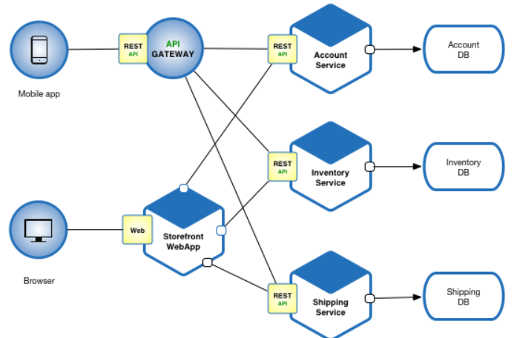

**Benefits of Microservice Architecture**

This solution has a number of benefits:

* Enables the continuous delivery and deployment of large, complex applications.
  + Better testability - services are smaller and faster to test
  + Better deployability - services can be deployed independently
  + It enables you to organize the development effort around multiple, auto teams. It enables you to organize the development effort around multiple teams. Each (two pizza) team is owns and is responsible for one or more single service. Each team can develop, deploy and scale their services independently of all of the other teams.
* Each microservice is relatively small
  + Easier for a developer to understand
  + The IDE is faster making developers more productive
  + The application starts faster, which makes developers more productive, and speeds up deployments
* Improved fault isolation. For example, if there is a memory leak in one service then only that service will be affected. The other services will continue to handle requests. In comparison, one misbehaving component of a monolithic architecture can bring down the entire system.
* Eliminates any long-term commitment to a technology stack. When developing a new service you can pick a new technology stack. Similarly, when making major changes to an existing service you can rewrite it using a new technology stack.

### **Drawbacks**

This solution has a number of drawbacks:

* Developers must deal with the additional complexity of creating a distributed system.
  + Developer tools/IDEs are oriented on building monolithic applications and don’t provide explicit support for developing distributed applications.
  + Testing is more difficult
  + Developers must implement the inter-service communication mechanism.
  + Implementing use cases that span multiple services without using distributed transactions is difficult
  + Implementing use cases that span multiple services requires careful coordination between the teams
* Deployment complexity. In production, there is also the operational complexity of deploying and managing a system comprised of many different service types.
* Increased memory consumption. The microservice architecture replaces N monolithic application instances with NxM services instances. If each service runs in its own JVM (or equivalent), which is usually necessary to isolate the instances, then there is the overhead of M times as many JVM runtimes. Moreover, if each service runs on its own VM (e.g. EC2 instance), as is the case at Netflix, the overhead is even higher.

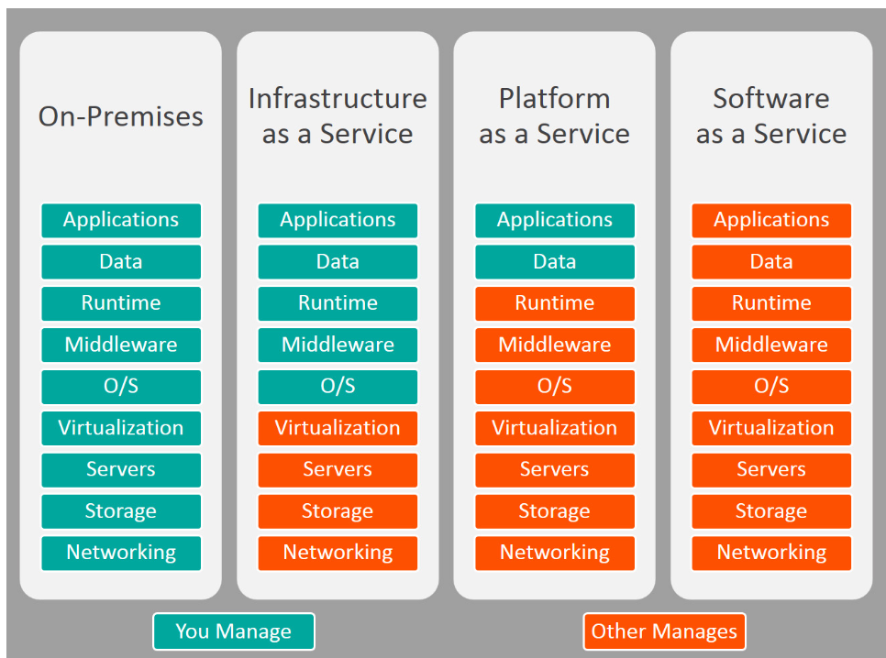

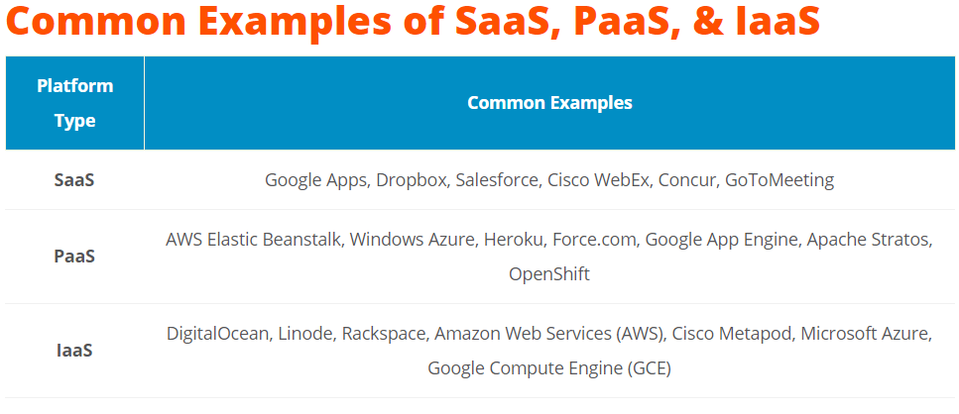

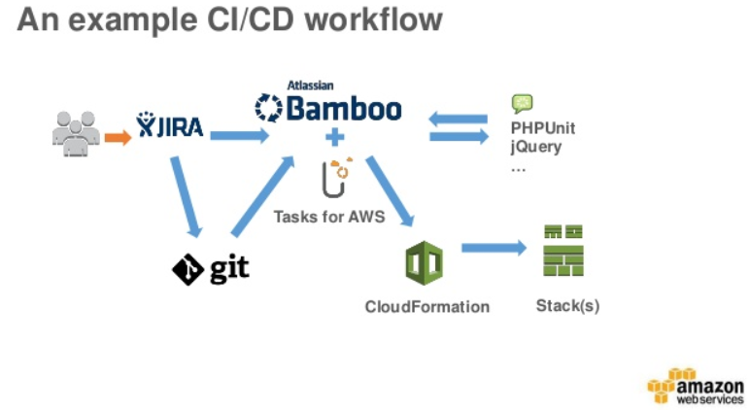

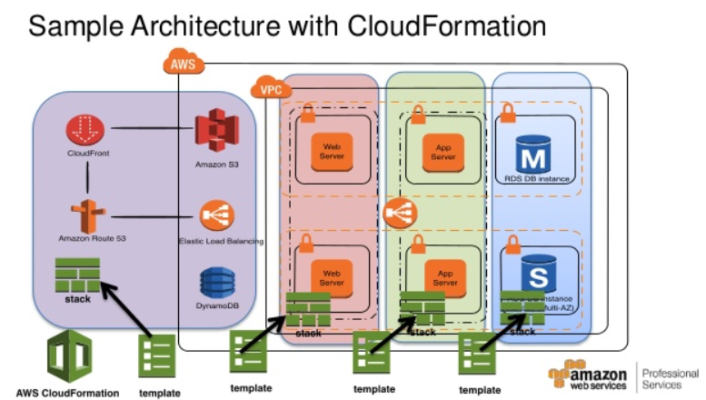

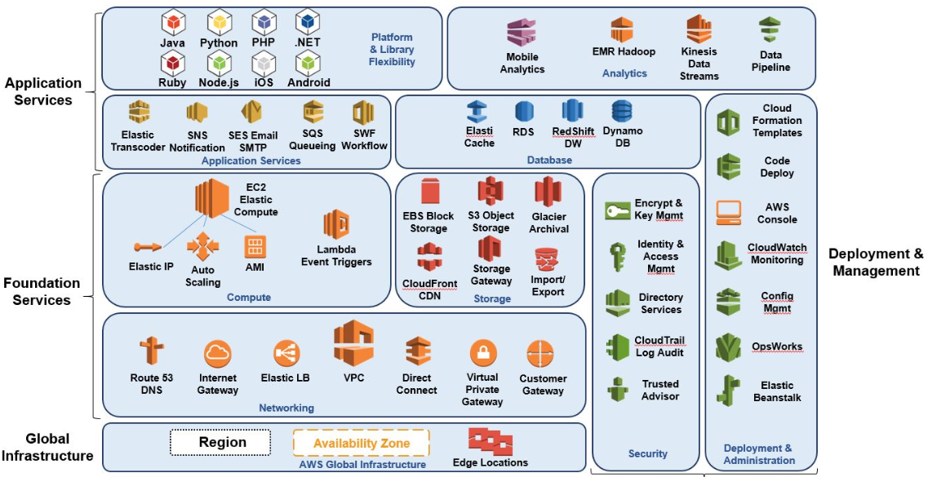

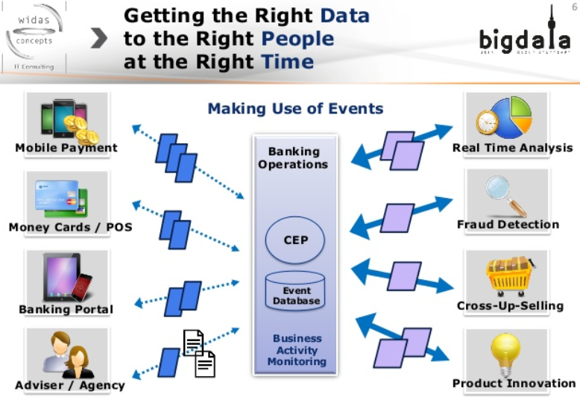

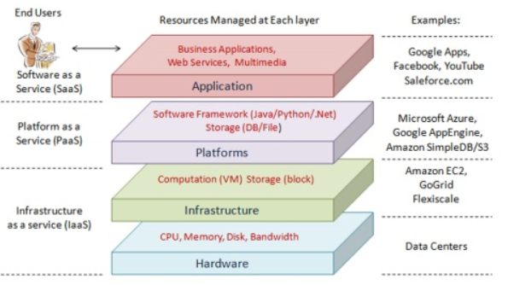

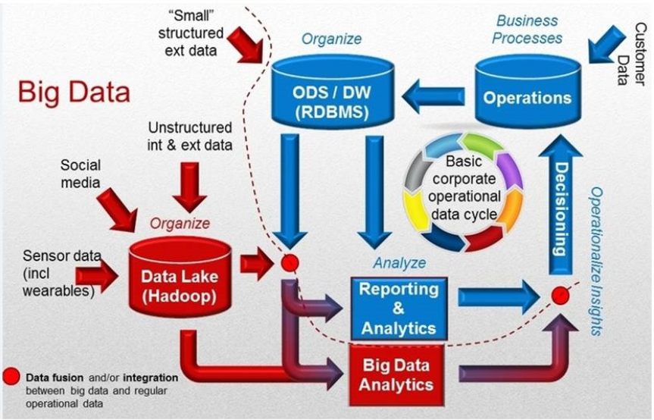

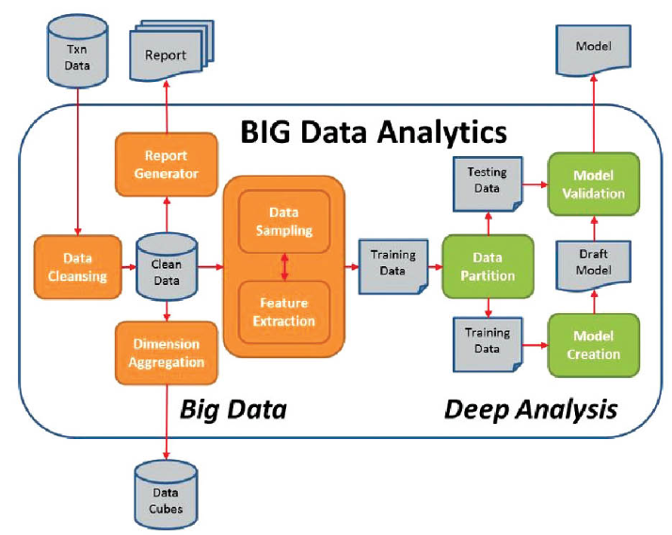

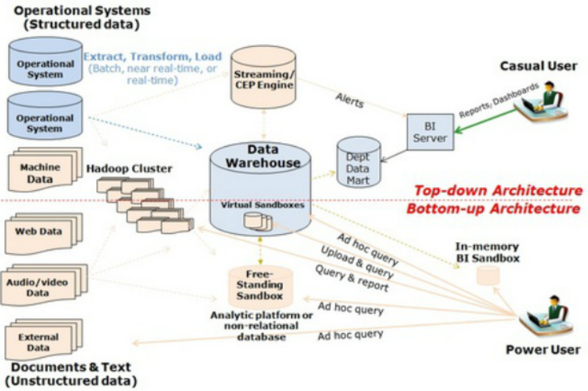

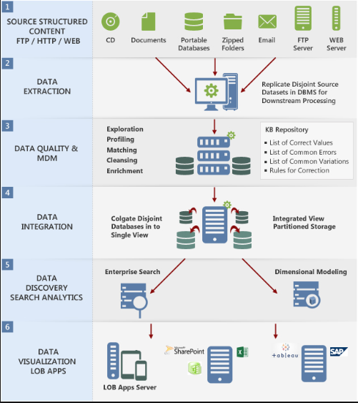

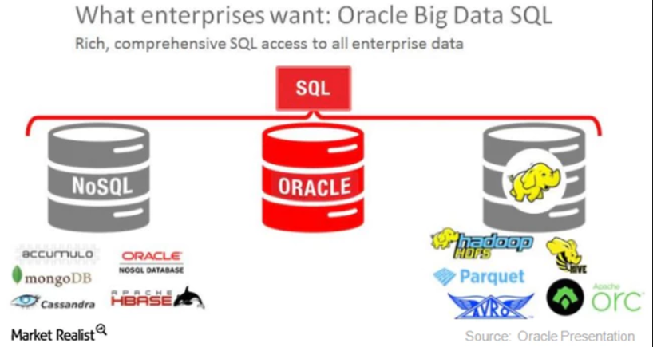

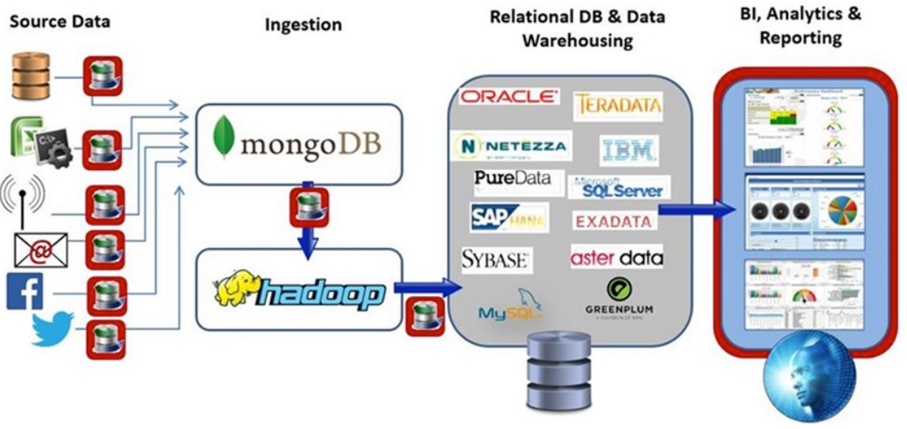

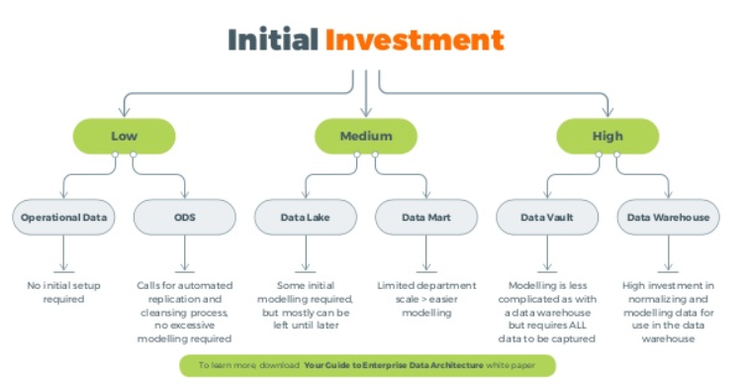

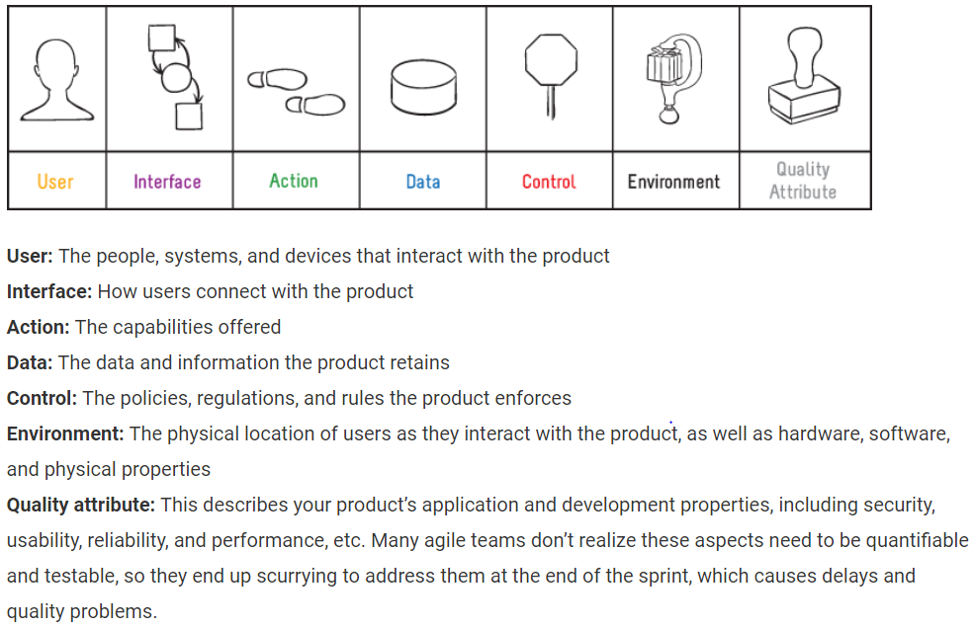

**Agile Concepts**

* The 7 Product Dimensions – stop gathering and start discovering
* The Business Value Model – vision, goals, objectives, value considerations
* Product options – identify product value
* Structured Conversations – explore, evaluation, and confirm
* Engage stakeholders as product partners
* User stories with 7 Product Dimensions, estimating
* Agile Discovery Workshops – role play collaborative requirements discovery
* Analysis tools – supplement user stories and scenarios with visual models
* Acceptance criteria – confirm you are building the right product
* Agile planning – product roadmaps, release plans, and iteration plans (Big-View, Pre-View and Now-View)
* Inspect and adapt – understand ways to leverage Discover to Deliver™ practices for your process and context

**Vision to Value: Backlog Refinement Practitioner –**

Through interactive discussions, examples, and dynamic exercises, you learn to:

Focus on value

* Align value with the product vision
* Use value as the foundation for backlog definition and refinement
* Make transparent, value-based product decisions
* Collaborate powerfully

Engineer strong collaboration among customers, business, and technology stakeholders in backlog definition and refinement

* Engage the right people at the right time
* Build and refine backlog items
* Explore, evaluate, and confirm product options with Structured Conversations
* Comprehensively refine backlog items across the 7 Product Dimension
* Confirm user stories with clear, unambiguous acceptance criteria
* Prepare backlog items for efficient release and sprint planning
* Slice user stories to be “ready” to get “done”

Learning these skills enables you to serve as a Backlog Refinement Practitioner, prepared to help your stakeholders collaborate as product partners, increase predictability in planning, improve smooth flow throughout sprints, and validate delivery of product value.

**Agile Business Analysis**

* Agile product discovery – ins and outs of agile business analysis
* Value – vision, goals, measurable objectives
* Product options – identify high-value features and user stories
* Structured Conversations – collaborate with stakeholders to analyze product needs quickly and holistically
* The 7 Product Dimensions – explore and evaluate product options
* Role play – give collaborative discovery a try
* Models – use lightweight tools to elicit, analyze and confirm requirements
* Functional requirements – analyze within and across the dimensions
* Product backlog – keep it refined and manageable
* Acceptance criteria – learn techniques to specify testable requirements
* Nonfunctional requirements – elevate and specify these often misunderstand and forgotten requirements
* Agile planning – estimate stories and minimum marketable features and allocate to plans
* Good agile analysis practices – your action plan
* Discover to Deliver™ – bring it all together with a fast-paced practicum

**The Essential Product Owner**

* Agile product owner essentials – attitudes and aptitudes for championing successful products
* Product vision – establish a compelling direction for your product
* Business value – identify value qualitatively and quantitatively
* Product options – choose high-value user stories and features
* Structured Conversation – collaborate to create a shared understanding among stakeholders
* The 7 Product Dimensions – explore, evaluate, and confirm
* Minimum Marketable Features – discover the smallest, high value feature set
* Product backlog – keep your backlog lean and organized
* Acceptance criteria – communicate and validate feature details
* Agile planning – create product roadmaps and release plans
* Good practices of agile product owners – your action plan

**Collaborating for Success**

* Agile teams – realize their unique make-up and opportunities
* Aptitudes and attitudes – discover the attributes of a skilled agile facilitator
* Opportunities for facilitation – outline types of agile sessions
* 6 Ps of Collaboration – apply purpose, participants, principles, products, place, and process to your session topic
* Facilitation roles – clarify roles needed for successful work sessions
* The facilitation stance – distinguishing coaching agile teams from facilitating them
* Collaboration Patterns – 8 powerful patterns for agile facilitation
* Focus questions – jumpstart activities with well-designed questions
* Conflict management – leverage the energy and making space for conflict
* Visual wall work – bring energy, focus, and innovation to your agile facilitation
* Structured Conversation – explore this approach for engaging a diverse group in collaborative agile requirements discovery
* Agile chartering – understand the value of Liftoffs to launch your team, project or service and ways to structure Liftoff sessions
* Big-View, Pre-View, Now-View – how to adapt facilitating sessions for these planning horizons to deliver product roadmaps, release plans, and iteration plans
* Visual management – engineer sessions to design agile teams’ visual management tools
* Retrospectives – ideas for planning and designing facilitated sessions enabling agile teams to truly inspect and adapt
* Requirements by Collaboration – design a mock session for collaboration
* Practice – facilitate a collaborative event
* Assess – evaluate your competencies and create a roadmap for development

**Scrum Release Planning.** A very high-level **plan** for multiple Sprints (e.g. three to twelve iteration) is created during the **Release planning**. It is a guideline that reflects expectations about which features will be implemented and when they are completed. It also serves as a base to monitor progress within the project.

To create a Release Plan the following things have to be available:

* A prioritized and estimated Scrum Product Backlog
* The (estimated) velocity of the Scrum Team
* Conditions of satisfaction (goals for the schedule, scope, resources)

Depending on the type of project (feature- or date-driven) the release plan can be created in different ways:  
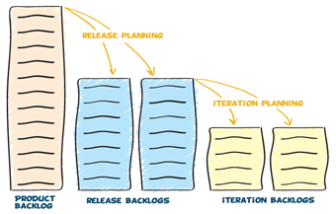

If the project is feature-driven, the sum of all features within in a release can be divided by the expected velocity. This will then result in the number of sprints needed to complete the requested functionality.

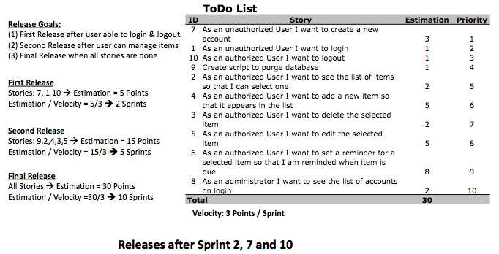  
**Release Plan for a feature-driven project**

If the project is date-driven we can simply multiply the velocity by the number of Sprints and we'll get the total work that can be completed within the given timeline.

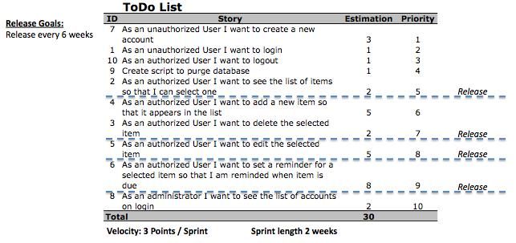  
**Release Plan for a date-driven project**

Like the Scrum Product Backlog the Release plan is not a static plan. It will change during the whole project when new knowledge is available and e.g. entries in the Scrum Product Backlog are changed and re-estimated. Therefore the Release Plan should be revisited and updated in regular intervals, e.g. after each Sprint.   
  
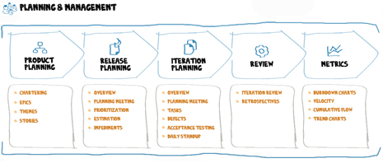

**The core agile software programming practices are the following:**

* Test-first programming (or perhaps Test-Driven Development),
* Rigorous, regular refactoring,
* Continuous integration,
* Simple design,
* Pair programming,
* Sharing the codebase between all or most programmers,
* A single coding standard to which all programmers adhere,
* A common “war-room” style work area.